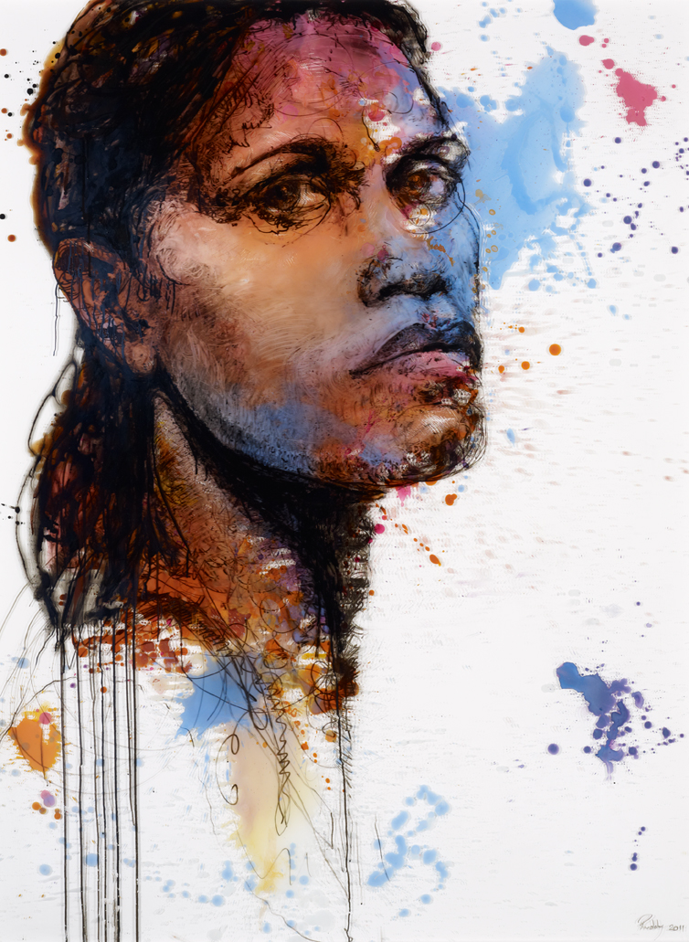
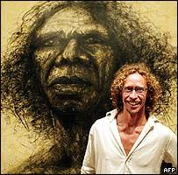
Instagram
Artteacher_alchemy
Onepalawawoman

YouTube
Art Teacher Alchemy Michelle Walker

Email
michellewalkerdesigns@gmail.com

Create own tools and pigments. Skills in value and proportion
Michelle Walker 2020

Unit Plan – 10 weeks

found art tools and Portraiture

A portrait that shows the viewer something about the subject.
The Archibald Prize and story in art
Make
Develop
Research

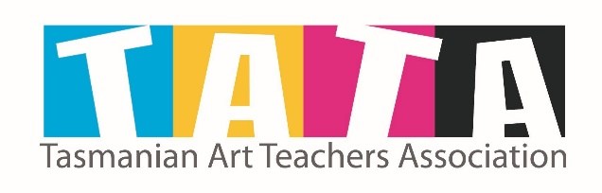
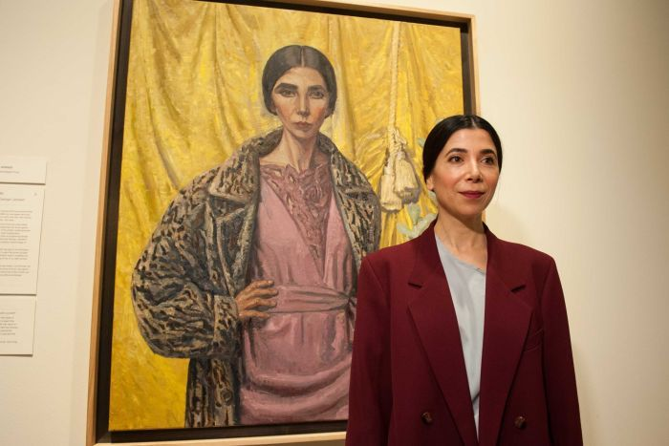
Table Of
Contents
Making Stage
Development Stage

This resource is included in TATA’s COVID19 visual art resources collection with appreciation and permission from its creator, Michelle Walker from Smithton High School, Tasmania. TATA does not have ownership of the IP (Intellectual Property) contained within the resources shared on this website. TATA acknowledges the generosity of sharing practice that underpins this collaborative resource sharing space, and ask that any on-sharing of resources acknowledge the originating IP of the Arts/Education professional/s who have contributed this resource, as well as any third party content acknowledged therein.

Resources
Research Stage
19

16

07

02

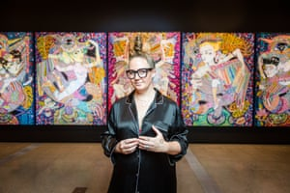
Research Stage

2 | Found art tools and portraiture

What that looks like:
Questions answered in good, complete sentences using good descriptive art language and the Principles and Elements of Design
- Knowledge about Australian artists and the Archibald Prize
- Choice of artist, images and annotations included
- Research into proposed portrait model and their story

Learning Intentions

By the end of this stage:
Students will know about the Archibald Prize and Australian Artists. Students will be able to talk about artist style and story telling in art

Research Criteria:

Conceptualise and develop representations of themes, concepts or subject matter to experiment with their developing personal style, reflecting on the styles of artists, including Aboriginal and Torres Strait Islander artists (ACAVAM125 - Scootle )

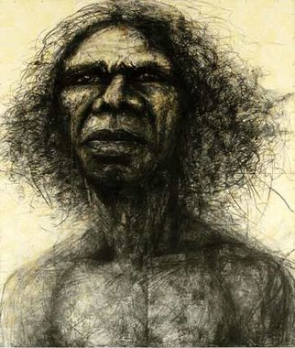

Working without ICT
Offline research and pictures has been provided in Resource Sections

Task #2:
Choose an artist that has either won or entered the Archibald Prize.
Print out images from that artist and write a brief bio. Annotate their artworks with good descriptive art language and Principles and Elements Vocabulary.

4 | Found art tools and portraiture

Research Stage

.Task #1:
For this week your task is to research The Archibald Prize and write at least one paragraph about it. Make sure to answer the following questions:
  - What is the Archibald Prize?
  - Who can enter the Archibald Prize?
  - What is the prize money?
  - What type of art works do you see and what is their subject matter?

Task #2:
Choose an artist that has either won or entered the Archibald Prize. Print out images from that artist and write a brief bio. Annotate their artworks with good descriptive art language and Principles and Elements Vocabulary.

Task #3:
Choose someone to complete a painted portrait on. It can be yourself or someone else you know in person. Please do not choose a celebrity or someone you do not have personal contact with.
Write about your portrait model. Include important things about their subject that could be included to help tell their subjects story in the portrait.
Try to get a photo of your model, you can use a mirror or a selfie if it is yourself. Print out the photo in colour and in black and white for use later in this project.
Think about what style of painting you might try to achieve? How might you achieve that? Will it be a proportional portrait, a cartoon, a symbolic or surreal portrait…..?

Make sure you include all of your thinking in your journal, please don't keep it to yourself

Winner: Archibald Prize 2004
Winner: People's Choice 2004

Craig Ruddy
Title: David Gulpilil, two worlds
Medium: mixed media on wallpaper on board
Dimensions: 240 x 204 cm
Credit © Craig Ruddy

Michelle Walker

One Week : Journal Work

What that looks like:
- Annotations use good descriptive language (Principles and Elements of Design) and reflection of experimentation.
- Effort put into practicing with materials.
- Sketch of proposed model has been edited and adjusted as needed.
- Consideration into telling the story of the model

Learning Intentions:

By the end of this stage:
Students will have experimented and created alternative tools and materials. Students will understand and complete activities in grey scale, proportion and value.

Research Criteria:
Manipulate materials, techniques, technologies and processes to develop and represent their own artistic intentions (ACAVAM126 - Scootle )

four WEEKS : Journal Work

DEVELOP STAGE

Make sure you include all of your thinking in your journal.
Tell the reader what you are thinking.
Don’t keep it to yourself.

Task #3:
Choose someone to complete a painted portrait on. It can be yourself or someone else you know in person. Please do not choose a celebrity or someone you do not have personal contact with.
Write about your portrait model. Include important things about the portrait subject that could be included to help tell the subjects story in the portrait.
Try to get a photo of your model, you can use a mirror or a selfie if it is yourself. Print out the photo in colour and in black and white for use later in this project.
Think about what style of painting you might try to achieve? How might you achieve that? Will it be a proportional portrait, a cartoon, a symbolic or surreal portrait? Will you try to replicate a style you discovered in your Research Stage?

6 | Found art tools and portraiture

ADORA

Working without ICT
Offline handouts have on creating your own brushes and inks are in the resources section
Video 1 - https://youtu.be/p_kWtreCeaI
Video 2 - https://youtu.be/_aJS6VBz2w4
Now it is time to find some pigments. What can you find to use?
Inspiration: coffee, black tea, melted chocolate, makeup, charcoal from the fire....
Ask permission from anyone that might be affected by you stealing their flowers or raiding their cupboards.
Think about what plants and flowers you have in the garden?
Tips: Mash them up and let them steep in cold water for a few days. Add some salt and vinegar if you would like to 'keep' them for a bit longer.
Mash them directly onto some paper and get the pigment out that way.
You can extract some pigments by boiling them but it does effect the colouring of the plant more drastically. Make your pigment stronger by boiling away excess moisture and strain out any 'bits'
What spices are in the kitchen cupboard?
Mix them with water, vinegar or methylated spirits for different experiments.
Complete some experiments with your new tools and pigments. Make sure you documented it in your journal.

8 | Found art tools and Portraiture

Week 1
This week we will be making our own tools and ink pigments.
Watch Video 1 on some tools that I have made.
Now it's time for you to go and gather some things that you might use. Annotate your findings into your journal.
Be safe when using sharp tools to carve and cut into your findings.

Please watch Video 2 on collecting pigments to turn into inks

Michelle Walker | 9

Video 3 – shows some of my experiments with handmade tools and found pigments.

Week 2
You will need - Resource Section:
Facial features – Grid Worksheets
Complete: at least, two gridded worksheets. Draw the first grid with the same dimensions and then complete the second larger grid to enlarge the drawing.
Extra: Complete your owns grids and proportional grey scale drawings from the photos of your model. You can focus just on certain elements of their face or draw the whole head.
Reflection: Glue the sheets into your journal and reflect on your efforts.
Tips: Begin with the main lines of the features. Look for where those main lines cross the grid lines and try to replicate that on your own grid. Shade in areas after the main lines are completed with as many shades of grey as you can.

Video 4 – shows the previous experiments that have dried and then has a look through my journal and other natural pigments and ink trial and errors.

Video 4 - https://youtu.be/OfrCOBmtoO4
Michelle Walker | 11

10 | Found art tools and Portraiture

Video 3 - https://youtu.be/1fc6PhMZ8SI
12 | Found art tools and Portraiture

Michelle Walker | 13

Video 5
Shows a grid portrait being constructed and then painted with coffee washes and details with grey lead pencil.

Video 5 - https://youtu.be/14Y4kashcxc
Week 3
This week we will draw our own grids and complete a grid drawing using our own inks
Do: Complete the grey scale grid drawings but using your own pigments or water colour as the paint. You can choose to use a paintbrush or tools you create.
Preferably you should be using your portrait subject (you or someone you know) to do this exercise.
If you don't have access to your printout/photos yet you can use a mirror. Use a white board or marker you can get off to rule up your grid onto the mirror. Prop up your mirror so it doesn't move and try to sit in a position in-which you can paint for a long time while still seeing the mirror.
Draw your own grid onto your paper or journal and onto your image or mirror. Begin drawing in the main lines quickly and then it should become easier to begin filling in your tones. Keep the lines light so that you will see them less after your painting is finished.
Add layers of colour/washes for the darker tones and leave white paper as the whitest tone.
Reflect: How did you go? Name two things you liked and one thing you would improve on. How did your paint/ink go? Did you like it? What would you change about it? How did it dry? Did it change?

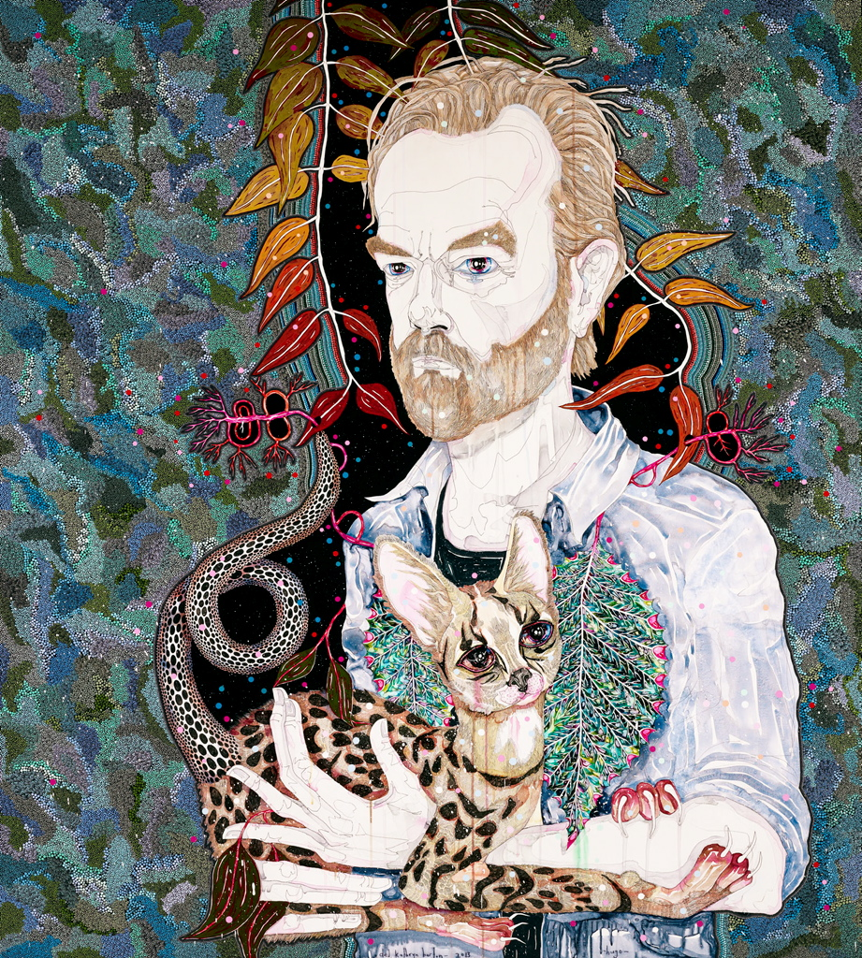
14 | Found art tools and Portraiture

Michelle Walker | 15

Video 5 - https://youtu.be/GVow8W8OeOs
Video 5 – shows how artist Del Katherine Barton prepared for her portrait of Hugo Weaving

Week 4

Planning Week for Final Art Work
To be completed and glued into journal. This weeks to do list:
- Find or collect any images you will need for inspiration
- Take photos or collect photos of portrait subject
- Write about portrait subjects story
- Brain storm ways to represent their story in your portrait. What will the story and its elements look like? How will that be represented through your personal or inspired art style?
- Complete sketches of proposed portrait. What will its main lines look like? How will that convey the meaning of the portraits story? Annotate using good descriptive art language.
- Practice with the medium (paint, ink, watercolour) that you intend to use. What skills to do you need to practice before starting? Can you blend colours? Will it be mono (one) colour or will you need to decide on your palette before starting? What will you paint onto? Do you need to practice on that?

Be ready to start your final art work for this unit next week!

Michelle Walker | 17

16 | Found art tools and Portraiture

4 – 5 weeks

Making Stage

Your final portrait must be from you or someone you know in real life.
Develop your own style of artwork. You can use any style of creating this artwork that you like but it must be completed with paints/ inks in some form.
You must show the viewer something about your model, good art tells a story.

Do: Using your sketches form your development stage, sketch in the main lines of your portrait.
Complete the painting using the value, proportional, tonal skills that you have learned.

Finishing: Do you need to back your work? If its on a canvas, do you need to paint your edges?

Reflect: In your journal reflect on your painting. Maybe you can add a photo of the finished artwork or add progressions shots as you are painting. Name two things you liked about your painting and one thing you would improve on.

If you make a mistake, don't worry, document it, learn from it then
keep going.

You've got this!

By the end of this stage:
Students will create a portrait that represents a person in their own style and show the viewer some narrative or story about the portrait model

Making Criteria:
Manipulate materials, techniques, technologies and processes to develop and represent their own artistic intentions (ACAVAM126 - Scootle )
What that looks like:
- A good portrait:
  - Tells the viewer something about the model
  - Shows value
  - Good blending of paints and use of materials
  - Student shows care when completing painting
  - Resilience when faced with difficulties, fails but tries again
  - Finishes on time

18 | Found art tools and Portraiture

Michelle Walker | 19

Resoursesection
Teacher Document: Unit Plan – Do not print out for students

 | Learning Area: Visual Art |  |  | Year Level: 7-10
Consult curriculum |  | Focus: Portraits, Proportions, Mono colour, Grey Scale, Value, Painting Techniques

Curriculum Achievement Standard:

Year 7-8
By the end of Year 8, students identify and analyse how other artists use visual conventions and viewpoints to communicate ideas and apply this knowledge in their art making. They explain how an artwork is displayed to enhance its meaning. They evaluate how they and others are influenced by artworks from different cultures, times and places.
Students plan their art making in response to exploration of techniques and processes used in their own and others’ artworks. They demonstrate use of visual conventions, techniques and processes to communicate meaning in their artworks.

Year 9-10
By the end of Year 10, students evaluate how representations communicate artistic intentions in artworks they make and view. They evaluate artworks and displays from different cultures, times and places. They analyse connections between visual conventions, practices and viewpoints that represent their own and others’ ideas. They identify influences of other artists on their own artworks.
Students manipulate materials, techniques and processes to develop and refine techniques and processes to represent ideas and subject matter in their artworks.

Curriculum Content Descriptors:

Year 7-8

Research:
Analyse how artists use visual conventions in artworks (ACAVAR123 - Scootle )

Develop:

Develop ways to enhance their intentions as artists through exploration of how artists use materials, techniques, technologies and processes (ACAVAM119 - Scootle )

Make:
Practise techniques and processes to enhance representation of ideas in their art-making (ACAVAM121 - Scootle )

Reflect:

Present artwork demonstrating consideration of how the artwork is displayed to enhance the artist’s intention to an audience (ACAVAM122 - Scootle

Year 9-10

Research:

Conceptualise and develop representations of themes, concepts or subject matter to experiment with their developing personal style, reflecting on the styles of artists, including Aboriginal and Torres Strait Islander artists (ACAVAM125 - Scootle )

Develop:

Develop and refine techniques and processes to represent ideas and subject matter (ACAVAM127 - Scootle )

Make:

Manipulate materials, techniques, technologies and processes to develop and represent their own artistic intentions (ACAVAM126 - Scootle )

Reflect:
Evaluate how representations communicate artistic intentions in artworks they make and view to inform their future art making(ACAVAR130 - Scootle )

Plan for learning |  | Learning Goals:  · Know (Research)  The Archibald Prize: Australian Artists involved  Students research on Australian artist that has been exhibited  Students can articulate an artist’s style, perspective and story telling  · Understand (Develop)  Scale, Grid drawing, Proportion, Grey Scale, Mono tone, Portraits  Found materials and Handmade Brushes  · Do (Make)  Complete a portrait (self or other) that represents the person through proportion and storytelling.
 | Assessment Task:  Formative – Journal Research, Good literacy and describing language in annotations, Experiments with brushes and found materials.  Summative – A finished portrait that tells a story about the featured person. |  |  | Pre-assessment :

Adjustments/Strategies to include all Students:
Learning at school:
Students will have access to their journals, computers and printers for research stage. Students will have access to all school materials and brushes. Students can choose the paper to complete the final portrait on.
Learning at Home with ICT:
Students will have access to Canvas and to video demonstrations. Students can adjust their materials to found pigments or supplies on hand. Students can request special materials to be picked up from the office.
Students who are unable to pick up journal can use any paper as necessary and for Research can be kept in a word document to print out at a later date to add to school journal.
Learning at Home without ICT:
Students will have printouts of Canvas written materials, Work sheets and materials supplied to those in need.
Students without journal can complete it on any paper or book as needed.
Students on Learning Plans:
Students can complete the portrait in any style that they can achieve. Students do not need to get accurate proportions, and shading. Students can concentrate on telling the story of their model (or themselves) through iconography, surrealism techniques, and symbolism.
Describe key learning experiences |  | Learning Sequence  Week 1:  Research Stage: Journal Work: Students should look at The Archibald Prize and answer some questions:  What is the Archibald Prize?  Who can enter the Archibald Prize?  What is the prize money?  What type of art works do you see and what is their subject matter?  Students should choose an artist that had either won or entered the art competition. Students can print out (if possible) images from that artist and write a brief bio on that artist. Annotate their artworks with good descriptive language and Principles and Elements Vocabulary.  Students should write about their proposed subject for the portrait. The portrait can be about themselves or about someone else. Students should try to get a photograph of their subject (where possible) or use a mirror where not possible. Students can print in colour and in black and white for the future.  Students should write important things about their subject that could be included to help tell their subjects story in a proposed portrait. What style is the student going to emulate? Will it be a proportional portrait, a cartoon, a symbolic portrait…..?  Week 2:  Develop Stage: Journal Work: Students should gather materials as necessary. Find supplies to use and make natural brushes as needed. See video.  Experiment with materials in journal or on paper.  Students at school or at home supplies can experiment with watercolours and found materials as able.  Experiments: Create mono tone washes. How weak/strong can you make your materials? Create a circle and make it darkest on the edges and work to lighter in the middle. Use your material on dry paper, Use your materials on wet paper. Sketch an outline of an object in your view. Sketch the negative and positive space left by that object in two separate drawings.  Annotate the experiments once dry. What is the student’s preferences? What did they notice about their materials? What would they change next time?  Week 3 -4 - 5:  Develop Stage: Journal Work:  Students to complete grey scale facial features worksheets with a pencil. Students can use the teacher supplied worksheets or make their own as required and able. Student should complete this with their intended subject as they are able.  Worksheets to be included in the journal as evidence of experimentation.  Students with found pigments (coffee, spices, etc) should repeat the process with their proposed material of choice.  Students with access to paints or material of choice should repeat the process with their materials.  Students should complete sketches or thumbnails of their proposed final piece. Annotations should be made as to how the portrait will reflect the models story in the final artwork.  Week 6-10:  Making Stage: Final Artwork:  Students to sketch out their portrait on to their medium of choice prior to beginning the painting component.  Complete painting.  Display or hand in for assessment.
Rubric |  | Rubric Considerations  Research  · Questions answered in good, complete sentences.  · Knowledge about Australian artists and the Archibald prize  · Choice of artist, images and annotations included.  · Research in to proposed Model and their story  Develop  · Annotations use good descriptive language (Principles and Elements of Design) and reflection of experimentation.  · Effort put into practicing with materials.  · Sketch of proposed model has been edited and adjusted as needed.  · Consideration into telling the story of the model  Make  A good portrait:  · Tells the viewer something about the model,  · Shows value  · Good blending of paints and use of materials.  · Student shows care when completing painting,  · Resilience when faced with difficulties  · Finishes on time

Research for Task 1 – Working from home without ICT
Reference: https://en.wikipedia.org/wiki/Archibald_Prize
The Archibald Prize was the first major prize for portraiture in Australian art. It was first awarded in 1921 after the receipt of a bequest from J. F. Archibald, the editor of The Bulletin who died in 1919. It is now administered by the trustees of the Art Gallery of New South Wales and awarded for "the best portrait, preferentially of some man or woman distinguished in Art, Letters, Science or Politics, painted by an artist resident in Australia during the twelve months preceding the date fixed by the trustees for sending in the pictures." The Archibald Prize has been awarded annually since 1921 (with two exceptions^{[1]}) and since July 2015 the prize has been AU$100,000.^{[2]}

Controversies
The prize has historically attracted a good deal of controversy and several court cases; the most famous was in 1943 when William Dobell's winning painting Mr Joshua Smith, a portrait of fellow artist Joshua Smith was challenged because of claims it was a caricature rather than a portrait.^{[14]}
Max Meldrum criticised the 1938 Archibald Prize winner, Nora Heysen, saying that women could not be expected to paint as well as men. Heysen was the first woman to win the Archibald Prize, with a portrait of Madame Elink Schuurman, the wife of the Consul General for the Netherlands.^{[15]}
In 1953 several art students including John Olsen protested William Dargie's winning portrait, the seventh time he had been awarded the prize. One protester tied a sign around her dog which said "Winner Archibald Prize – William Doggie".^{[16]} Dargie went on to win the prize again in 1956.
On becoming Prime Minister in 1972, Gough Whitlam commissioned his friend Clifton Pugh to paint the official portrait. Normally the Australian Parliament Historical Memorial Committee would have commissioned a portrait.^{[17][18]} Pugh's portrait of Whitlam won the 1972 Archibald Prize.^{[19]}
In 1975, John Bloomfield's portrait of Tim Burstall was disqualified on the grounds that it had been painted from a blown up photograph, rather than from life.^{[20]} The prize was then awarded to Kevin Connor. In 1983 John Bloomfield sued for the return of the 1975 prize which was unsuccessful.^{[21]} The application form of the Archibald Prize was modified based on this to make clear that the subject must be painted from life.^{[9]}
In 1985, administration of the trust was transferred to the Art Gallery of New South Wales, after a court case where the Perpetual Trustee Company took the Australian Journalists Association Benevolent Fund to court.^{[22]}
In 1997 the painting of the Bananas in Pyjamas television characters by Evert Ploeg was deemed ineligible by the trustees because it was not a painting of a person.^{[23]}
Another controversy involved the 2000 Archibald winner, when artist Adam Cullen lodged a complaint with the Australian Broadcasting Corporation who had used his painting, Portrait of David Wenham, in a television commercial.^{[24]}
In 2002, head packer Steve Peters singled out a painting of himself by Dave Machin as a possible winner for the Packing Room Prize. It did not win, but it was hung outside the Archibald exhibition. Following this, portraits of the head packer were no longer allowed.^{[25]}
In 2004 Craig Ruddy's image of David Gulpilil, which won both the main prize and the "People's Choice" award, was challenged on the basis that it was a charcoal sketch rather than a painting. The claim was dismissed in the Supreme Court of New South Wales in June 2006.^{[26][27]}
In 2008 Sam Leach's image of himself in a Nazi uniform made the front page of Melbourne's newspaper The Age^{[28]} and sparked a national debate about the appropriateness of his choice of subject matter. The prize money was also changed to $50,000.

Research for Task 2 – Working from home without ICT
Also- use the pictures from Craig Ruddy in the research stage

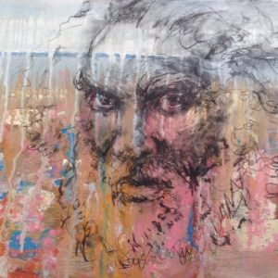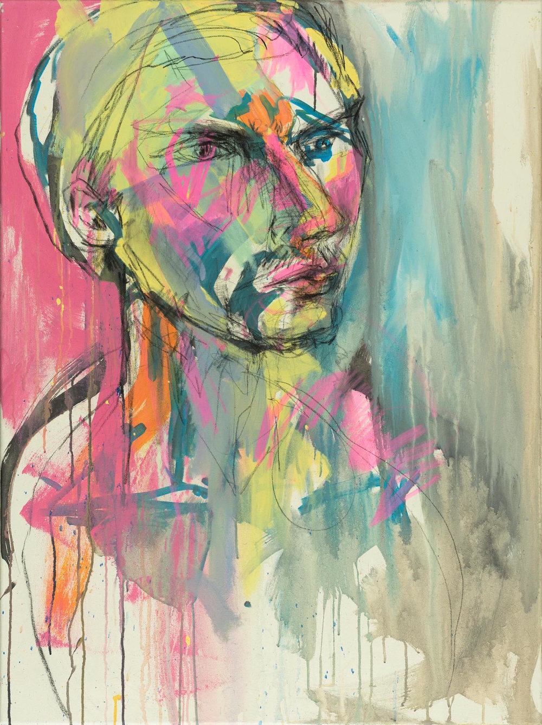

Research for Task 2 – Working from home without ICT
Also- use the pictures from Craig Ruddy in the research stage

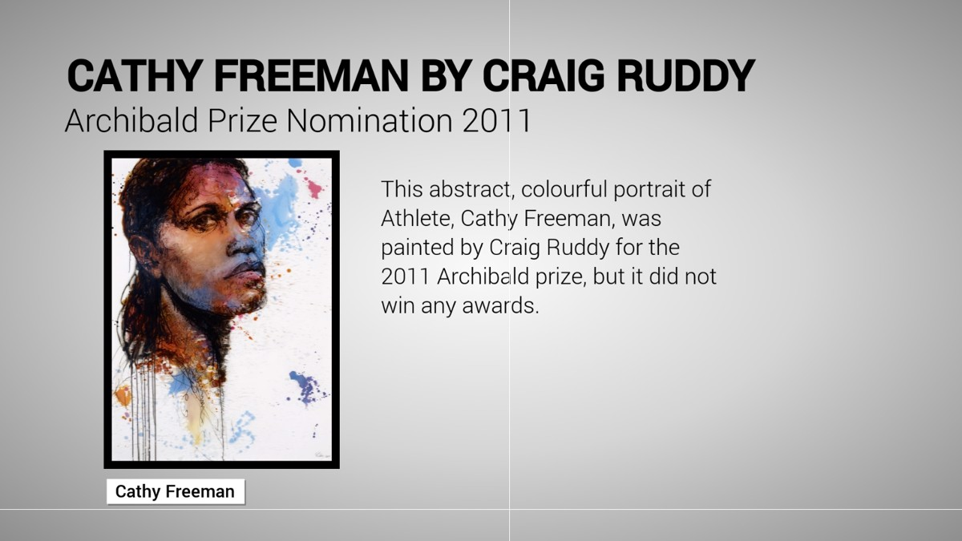
Reference: http://harveygalleries.com.au/artist/craig-ruddy/
BORN 1968 Sydney
ABOUT
Craig Ruddy is an award winning contemporary artist who lives and works in The Pocket in Northern NSW Australia.
Craig Ruddy is renowned for his dramatic figurative portraits that are often interwoven into richly textured abstracted landscapes. Ruddy’s art practice explores the space between our real and mythical connections to the land and environment. His work reflects a deeply personal ongoing spiritual journey, where the artist explores questions of social conscience as well as current environmental issues. The recognition of Australian Indigenous People and Culture is also a core theme that has permeated the narrative of his past work and exhibitions.
Craig Ruddy’s inimitable painting style pushes the traditional boundaries of this classic medium. His work process involves a complex layering of mixed mediums that include paint, charcoal, pencil drawing, varnish and even glass. Ruddy’s figures become inseparable from the landscapes in which they reside. His unique use of layering creates an illusion of transparency, whereby the foreground and background seem to both simultaneously co-exist and disappear, becoming one and the same. The illusory technique mirrors a deeper spiritual metaphor; the interconnectedness of all things.
The artist’s work is a continuing tribute to his surroundings, country and the people that reside within it. Ruddy’s practice is intuitive and organic. His use of free flowing sensitive lines combined with a vibrant dynamic colour palate result in bold paintings that are both sensual and powerful, aptly reflecting the inspiration he draws from the Australian landscape.
EARLY LIFE / CAREER
Born in Forestville in 1968, Craig Ruddy grew up surrounded by natural bushland living near Ku-ring-gai Chase and Garigal National Parks. The unique circumstances of his childhood and surrounding environment were to have a significant lifelong impact on the artist.
As a child, Craig Ruddy was plagued with a life threatening illness, unsure whether he would live to adulthood his parents greatly limited his physical activities. Ruddy hence turned his attention to drawing and painting. His ongoing illness gave early rise to profound existential questions and imbued Ruddy with a sensibility and need to question his sense of place within his vast natural surroundings. This early period of life greatly influenced the artists practice and the questions raised in childhood are themes which continue to define the narrative of his work today.
In the late 1980’s Craig Ruddy studied design and fashion illustration in Sydney. He worked as a landscape gardener, designer and art director, eventually settling down in Sydney’s beachside suburb of Tamarama. Craig’s home in the Eastern suburbs became a revolving door for many of the international travelers, artists and bohemians passing through Sydney at the time. This exposure to new energy from abroad and fresh ideas was to create a pivotal turning point in his life. Inspired and encouraged by his friends, in 2001 he took a leap of faith and quit his successful design career in order to pursue his life-long passion for art and painting.
In 2004 he came to the attention of the wider community upon winning Australia’s most prestigious painting prize for his highly controversial and publicized portrait of Aboriginal actor David Gulpilil. Craig Ruddy became one of the most talked about winners in the history of the Archibald Prize. His seminal portrait was profoundly important for Australia with its timely message about indigenous recognition and reconciliation. The prize winning painting became the subject of an unsuccessful NSW Supreme Court challenge by another artist who claimed the portrait was not a painting and ineligible for the prize as it was predominantly created with charcoal. After an epic two- year court battle the case was eventually dismissed. The controversy however became etched in the collective memory, and Ruddy’s portrait of David Gulipili is now considered one of the most iconic and recognized paintings in Australia.
Following the success of many sold out solo shows in Sydney, Craig Ruddy travelled for several years between Europe and South America in order to continue and develop his art practice. He set up a secondary home and studio in Buenos Aires Argentina.
In 2015 Craig Ruddy felt a strong pull to once again reconnect to nature and the land which had so greatly influenced his work. He moved back to Australia to build a studio in the Byron Hinterland nestled in the hilltops and surrounded by bushland where he feels most at home and inspired.
ARCHIBALD PRIZE
The Archibald Prize is the most prestigious painting prize in Australia, awarded annually to the best portrait, ‘preferentially of some man or woman distinguished in art, letters, science or politics, painted by any artist resident in Australasia’.
This open competition is judged by the trustees of the Art Gallery of NSW. Finalists are displayed in an exhibition at the Gallery.
The Archibald Prize was first awarded in 1921. In establishing the prize, JF Archibald’s aim was to foster portraiture as well as support artists and perpetuate the memory of great Australians. Over the years some of Australia’s most prominent artists have entered and the subjects have been equally celebrated in their fields.
CRAIG RUDDY AND THE ARCHIBALD PRIZE
Craig Ruddy has been a winner and finalist of the Archibald prize and the People’s Choice Award.
2003/ Self Portrait
Salon des refuses – National Trust – S.H.Ervin Gallery
2004 / Portrait of David Gulpilil “Two Worlds”
Archibald Prize Winner
Winner of the People’s choice award in Sydney and Melbourne.
David Gulpilil Ridjimiraril Dalaithngu AM, is an Aboriginal actor and traditional dancer.
Link: https://www.artgallery.nsw.gov.au/prizes/archibald/2004/27945/
2006/ Self Portrait “Into the box”
Finalist Archibald Prize
Link: https://www.artgallery.nsw.gov.au/prizes/archibald/2006/28291/
2010 / Portrait of Warwick Thornton “The Prince of Darkness”.
Archibald Prize Finalist
Winner of the people’s choice award
Warwick Thornton is an aboriginal writer/director, won the Camera d’Or for Best Feature Film at the 2009 Cannes Film Festival for Samson & Delilah.
Link: https://www.artgallery.nsw.gov.au/prizes/archibald/2010/29087/
2011 / Portrait of Cathy Freeman
Archibald Prize Finalist
Cathy Freeman is an Aboriginal Olympic Gold Medallist
Link: https://www.artgallery.nsw.gov.au/prizes/archibald/2011/28932/
Selected recent works
AWAKENING SPIRIT 2017
In his latest exhibition “Awakening Spirit”, Ruddy acknowledges the Indigenous Australian’s that continue to remain invisible. These new works aim to represent the voices that have gone unheard as well as those still present that are continuing to fight for their human rights. It is a work of recognition as to the resilience of a people, who maintain their cultural connection & sovereign responsibility to look after country, despite the great challenge of upholding their heritage in the face of continued colonisation and industrialisation.
WILD GRASS 2016
In Wild Grass, the constant motion of the Australian wild grass in the landscape reminds us of what is important for us to successfully exist in a place. Tangled bodies become one with the ground and sky, as the sensual drifting lines of Craig Ruddy’s nudes morph into the landscape. The powerful and evocative picture plane works as a visual metaphor for our human desire to be connected to our environment. Residing in the Byron hinterland of Northern NSW, the environment has become a powerful influence for the artist. Ruddy’s close proximity to the natural world has provided direction and constant inspiration. This fresh energy combined with Ruddy’s mastery of effortless composition, see lines and layers dance across the picture, rhythmically and raw. The works are powerful and dynamic in their rendering of the human connection with sensuality and the land.

EARLY LIFE / CAREER
Born in Forestville in 1968, Craig Ruddy grew up surrounded by natural bushland living near Ku-ring-gai Chase and Garigal National Parks. The unique circumstances of his childhood and surrounding environment were to have a significant lifelong impact on the artist.
As a child, Craig Ruddy was plagued with a life threatening illness, unsure whether he would live to adulthood his parents greatly limited his physical activities. Ruddy hence turned his attention to drawing and painting. His ongoing illness gave early rise to profound existential questions and imbued Ruddy with a sensibility and need to question his sense of place within his vast natural surroundings. This early period of life greatly influenced the artists practice and the questions raised in childhood are themes which continue to define the narrative of his work today.
In the late 1980’s Craig Ruddy studied design and fashion illustration in Sydney. He worked as a landscape gardener, designer and art director, eventually settling down in Sydney’s beachside suburb of Tamarama. Craig’s home in the Eastern suburbs became a revolving door for many of the international travelers, artists and bohemians passing through Sydney at the time. This exposure to new energy from abroad and fresh ideas was to create a pivotal turning point in his life. Inspired and encouraged by his friends, in 2001 he took a leap of faith and quit his successful design career in order to pursue his life-long passion for art and painting.
In 2004 he came to the attention of the wider community upon winning Australia’s most prestigious painting prize for his highly controversial and publicized portrait of Aboriginal actor David Gulpilil. Craig Ruddy became one of the most talked about winners in the history of the Archibald Prize. His seminal portrait was profoundly important for Australia with its timely message about indigenous recognition and reconciliation. The prize winning painting became the subject of an unsuccessful NSW Supreme Court challenge by another artist who claimed the portrait was not a painting and ineligible for the prize as it was predominantly created with charcoal. After an epic two- year court battle the case was eventually dismissed. The controversy however became etched in the collective memory, and Ruddy’s portrait of David Gulipili is now considered one of the most iconic and recognized paintings in Australia.
Following the success of many sold out solo shows in Sydney, Craig Ruddy travelled for several years between Europe and South America in order to continue and develop his art practice. He set up a secondary home and studio in Buenos Aires Argentina.
In 2015 Craig Ruddy felt a strong pull to once again reconnect to nature and the land which had so greatly influenced his work. He moved back to Australia to build a studio in the Byron Hinterland nestled in the hilltops and surrounded by bushland where he feels most at home and inspired.
ARCHIBALD PRIZE
The Archibald Prize is the most prestigious painting prize in Australia, awarded annually to the best portrait, ‘preferentially of some man or woman distinguished in art, letters, science or politics, painted by any artist resident in Australasia’.
This open competition is judged by the trustees of the Art Gallery of NSW. Finalists are displayed in an exhibition at the Gallery.
The Archibald Prize was first awarded in 1921. In establishing the prize, JF Archibald’s aim was to foster portraiture as well as support artists and perpetuate the memory of great Australians. Over the years some of Australia’s most prominent artists have entered and the subjects have been equally celebrated in their fields.
CRAIG RUDDY AND THE ARCHIBALD PRIZE
Craig Ruddy has been a winner and finalist of the Archibald prize and the People’s Choice Award.
2003/ Self Portrait
Salon des refuses – National Trust – S.H.Ervin Gallery
2004 / Portrait of David Gulpilil “Two Worlds”
Archibald Prize Winner
Winner of the People’s choice award in Sydney and Melbourne.
David Gulpilil Ridjimiraril Dalaithngu AM, is an Aboriginal actor and traditional dancer.
Link: https://www.artgallery.nsw.gov.au/prizes/archibald/2004/27945/
2006/ Self Portrait “Into the box”
Finalist Archibald Prize
Link: https://www.artgallery.nsw.gov.au/prizes/archibald/2006/28291/
2010 / Portrait of Warwick Thornton “The Prince of Darkness”.
Archibald Prize Finalist
Winner of the people’s choice award
Warwick Thornton is an aboriginal writer/director, won the Camera d’Or for Best Feature Film at the 2009 Cannes Film Festival for Samson & Delilah.
Link: https://www.artgallery.nsw.gov.au/prizes/archibald/2010/29087/
2011 / Portrait of Cathy Freeman
Archibald Prize Finalist
Cathy Freeman is an Aboriginal Olympic Gold Medallist
Link: https://www.artgallery.nsw.gov.au/prizes/archibald/2011/28932/
Selected recent works
AWAKENING SPIRIT 2017
In his latest exhibition “Awakening Spirit”, Ruddy acknowledges the Indigenous Australian’s that continue to remain invisible. These new works aim to represent the voices that have gone unheard as well as those still present that are continuing to fight for their human rights. It is a work of recognition as to the resilience of a people, who maintain their cultural connection & sovereign responsibility to look after country, despite the great challenge of upholding their heritage in the face of continued colonisation and industrialisation.
WILD GRASS 2016
In Wild Grass, the constant motion of the Australian wild grass in the landscape reminds us of what is important for us to successfully exist in a place. Tangled bodies become one with the ground and sky, as the sensual drifting lines of Craig Ruddy’s nudes morph into the landscape. The powerful and evocative picture plane works as a visual metaphor for our human desire to be connected to our environment. Residing in the Byron hinterland of Northern NSW, the environment has become a powerful influence for the artist. Ruddy’s close proximity to the natural world has provided direction and constant inspiration. This fresh energy combined with Ruddy’s mastery of effortless composition, see lines and layers dance across the picture, rhythmically and raw. The works are powerful and dynamic in their rendering of the human connection with sensuality and the land.

Finalist Archibald Prize
Link: https://www.artgallery.nsw.gov.au/prizes/archibald/2006/28291/
2010 / Portrait of Warwick Thornton “The Prince of Darkness”.
Archibald Prize Finalist
Winner of the people’s choice award
Warwick Thornton is an aboriginal writer/director, won the Camera d’Or for Best Feature Film at the 2009 Cannes Film Festival for Samson & Delilah.
Link: https://www.artgallery.nsw.gov.au/prizes/archibald/2010/29087/
2011 / Portrait of Cathy Freeman
Archibald Prize Finalist
Cathy Freeman is an Aboriginal Olympic Gold Medallist
Link: https://www.artgallery.nsw.gov.au/prizes/archibald/2011/28932/
Selected recent works
AWAKENING SPIRIT 2017
In his latest exhibition “Awakening Spirit”, Ruddy acknowledges the Indigenous Australian’s that continue to remain invisible. These new works aim to represent the voices that have gone unheard as well as those still present that are continuing to fight for their human rights. It is a work of recognition as to the resilience of a people, who maintain their cultural connection & sovereign responsibility to look after country, despite the great challenge of upholding their heritage in the face of continued colonisation and industrialisation.
WILD GRASS 2016
In Wild Grass, the constant motion of the Australian wild grass in the landscape reminds us of what is important for us to successfully exist in a place. Tangled bodies become one with the ground and sky, as the sensual drifting lines of Craig Ruddy’s nudes morph into the landscape. The powerful and evocative picture plane works as a visual metaphor for our human desire to be connected to our environment. Residing in the Byron hinterland of Northern NSW, the environment has become a powerful influence for the artist. Ruddy’s close proximity to the natural world has provided direction and constant inspiration. This fresh energy combined with Ruddy’s mastery of effortless composition, see lines and layers dance across the picture, rhythmically and raw. The works are powerful and dynamic in their rendering of the human connection with sensuality and the land.
REMNANTS – of an urban landscape.
Suburban waste bins become the focus of these abstract landscapes. The body of work explores the human mind as an open vast landscape obstructed by glimpses of perceived reality, etched with remnants of the past. We are simply vessels suspended in time, stitched to the eternal passage of life and death as we fill ourselves, empty, and then fill again.
Like ancient ruins, waste bins scattered throughout our urban landscapes become metaphors for the memories of their owners, the remnants that are left in ones mind by the constant flux of life. Past memories, some fully loaded others sprawled empty. Each is potent with its sense in being, though many remain simply as waste, like scratches on a rolling film. We grasp at them constantly in an attempt to complete a picture, to understand what has been before and to foresee a path ahead, weaving between parallel universes, spinning our web to which we cling to as life.
EXHIBITIONS
Craig Ruddy exhibits regularly and his works are held in numerous important private collections both in Australia and internationally. He has had solo exhibitions at the Cork Street Gallery in London, Nanda Hobbs Contemporary, Richard Martin, Harvey Galleries, Graphis Gallery, Fringe Festival and S.H. Ervin Gallery in Sydney, as well as in group exhibitions at many Australian institutions including the Art Gallery of New South Wales, Faux Mo MONA, Broken Hill Art Gallery and Victoria Arts Centre.

Research for Task 3 – Working from home without ICT

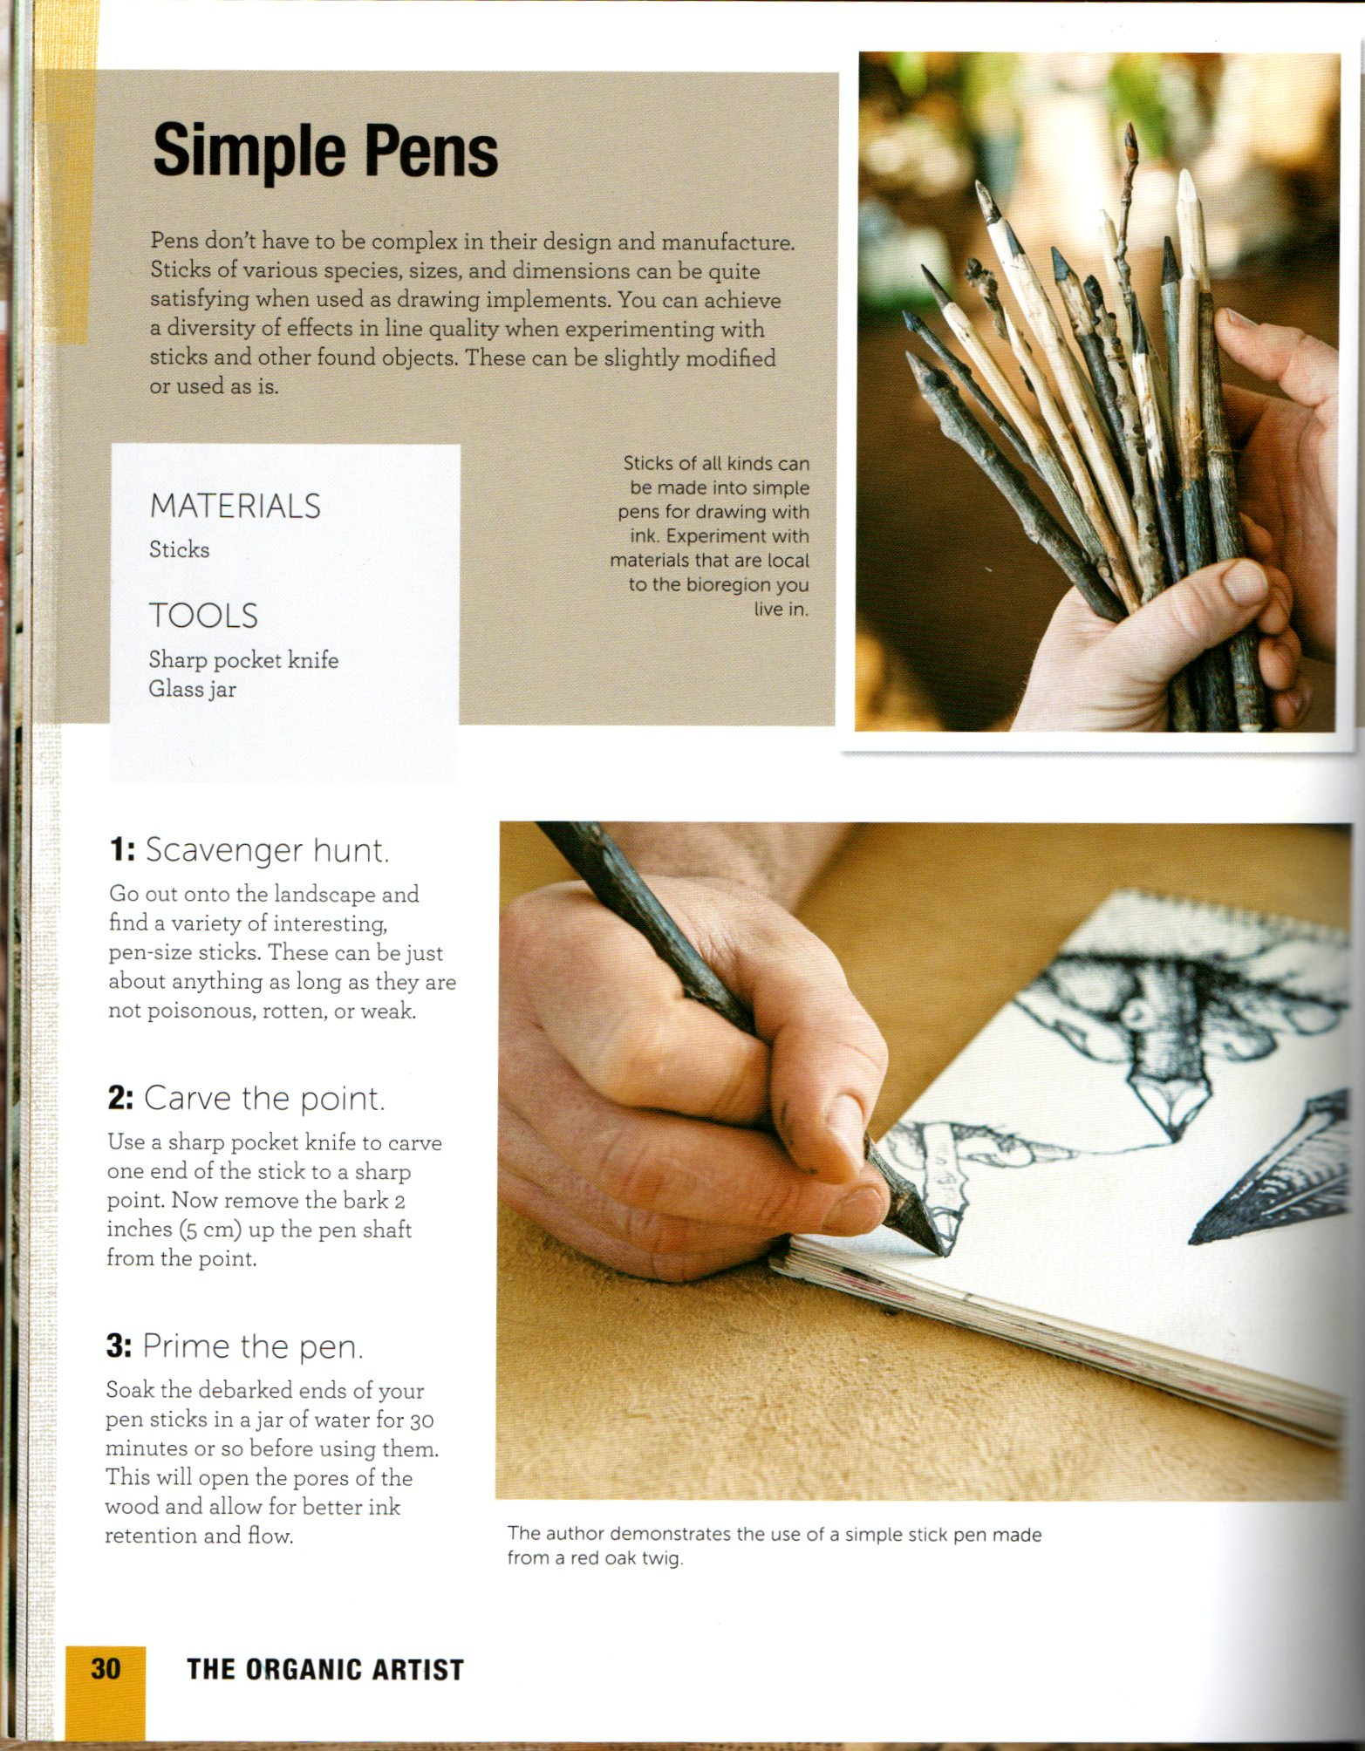
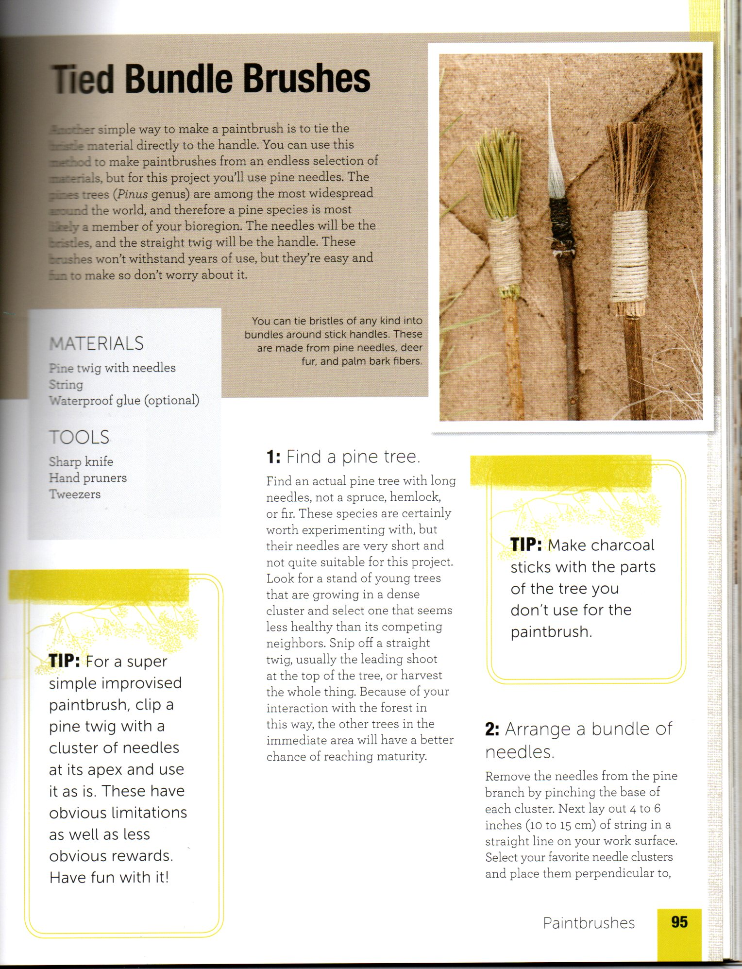

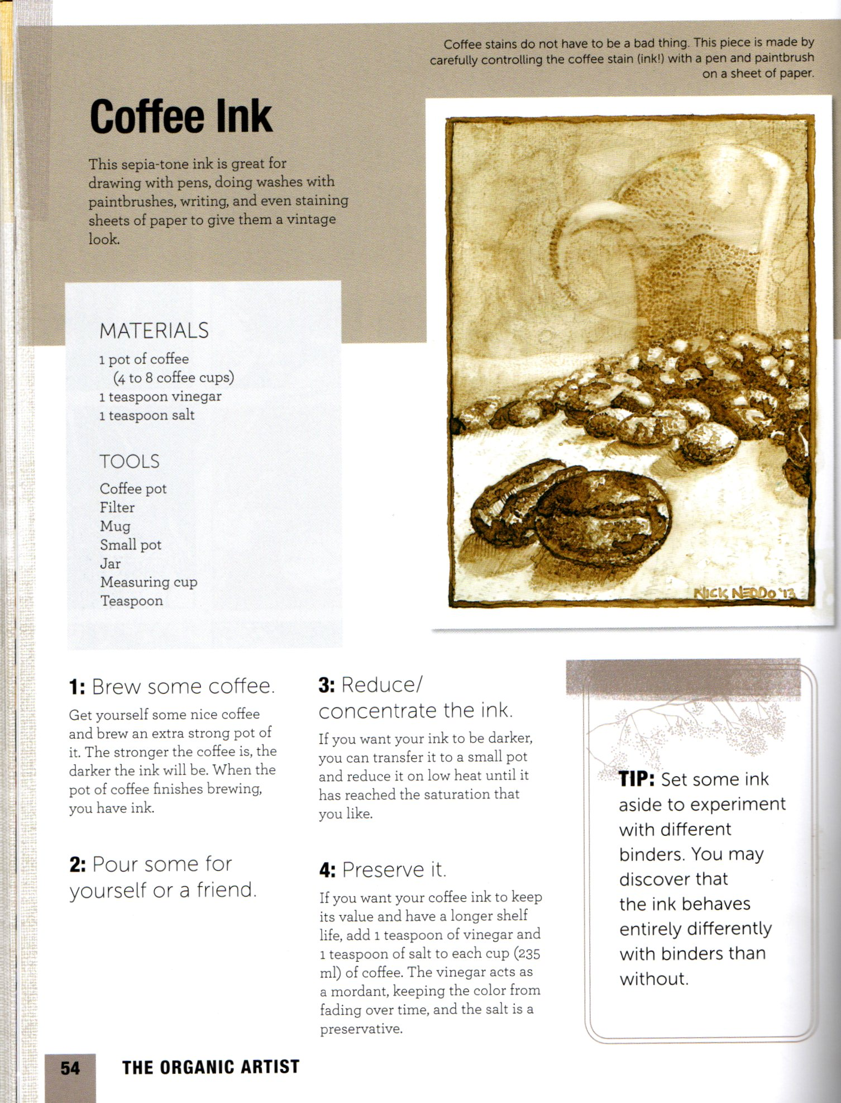
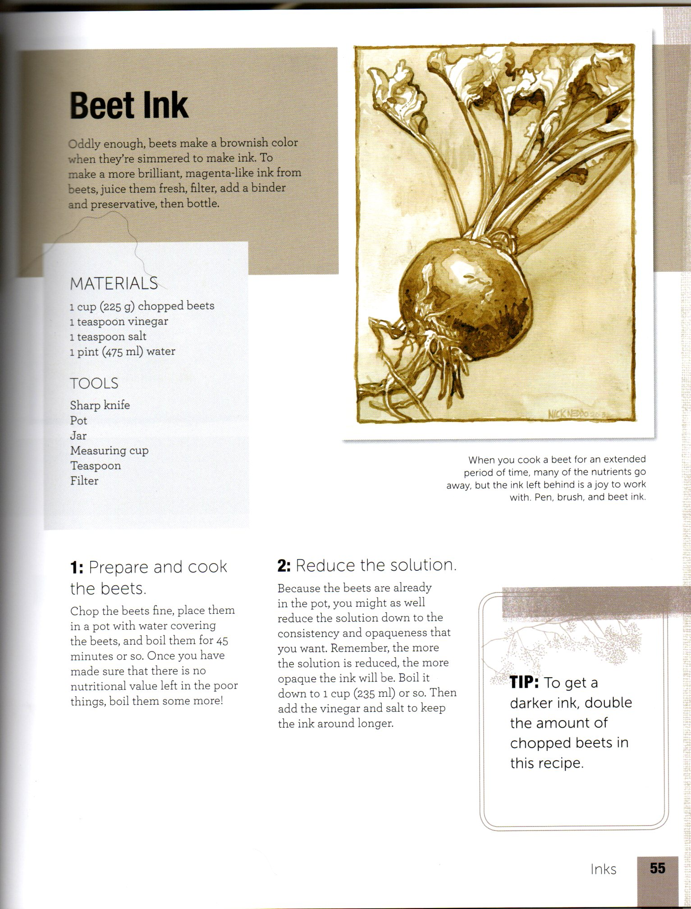
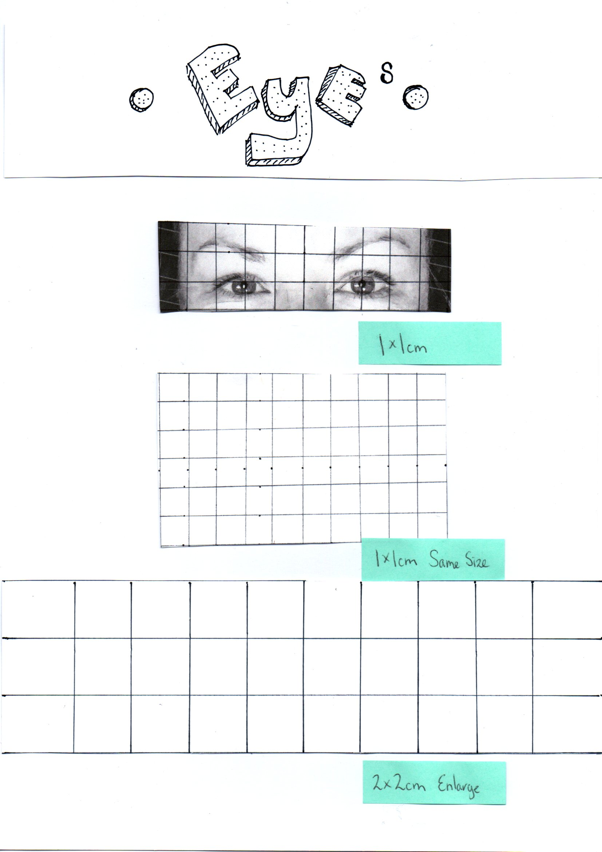
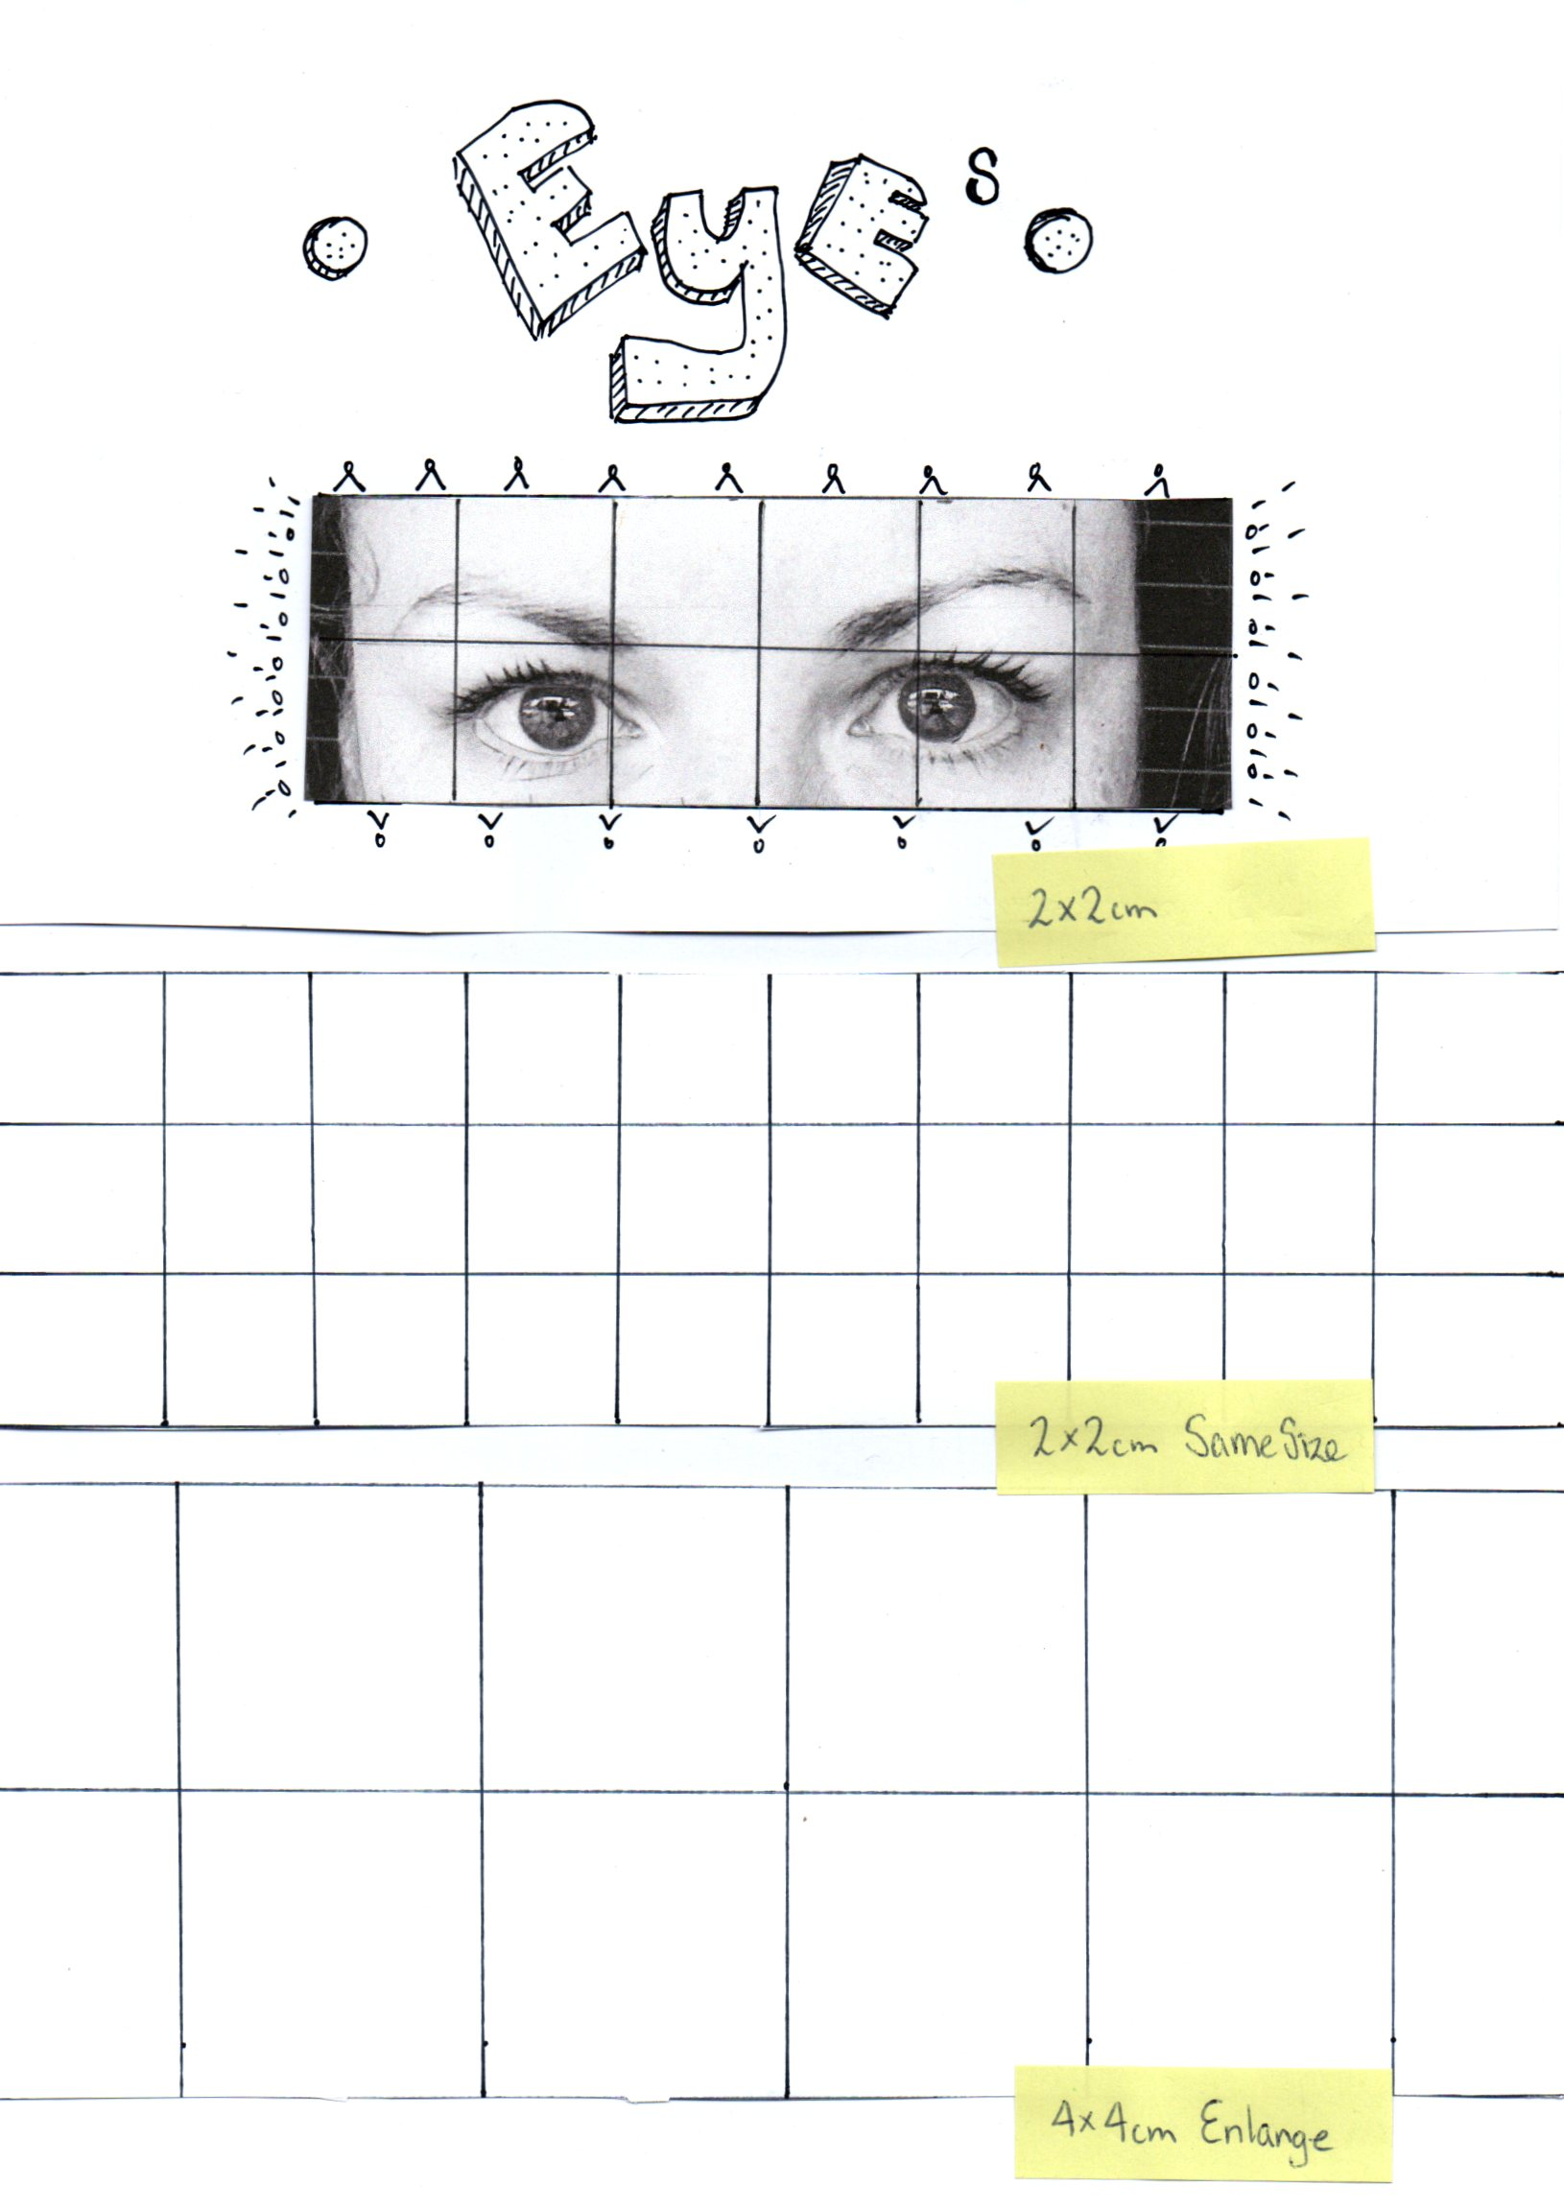
Develop grid portraits

