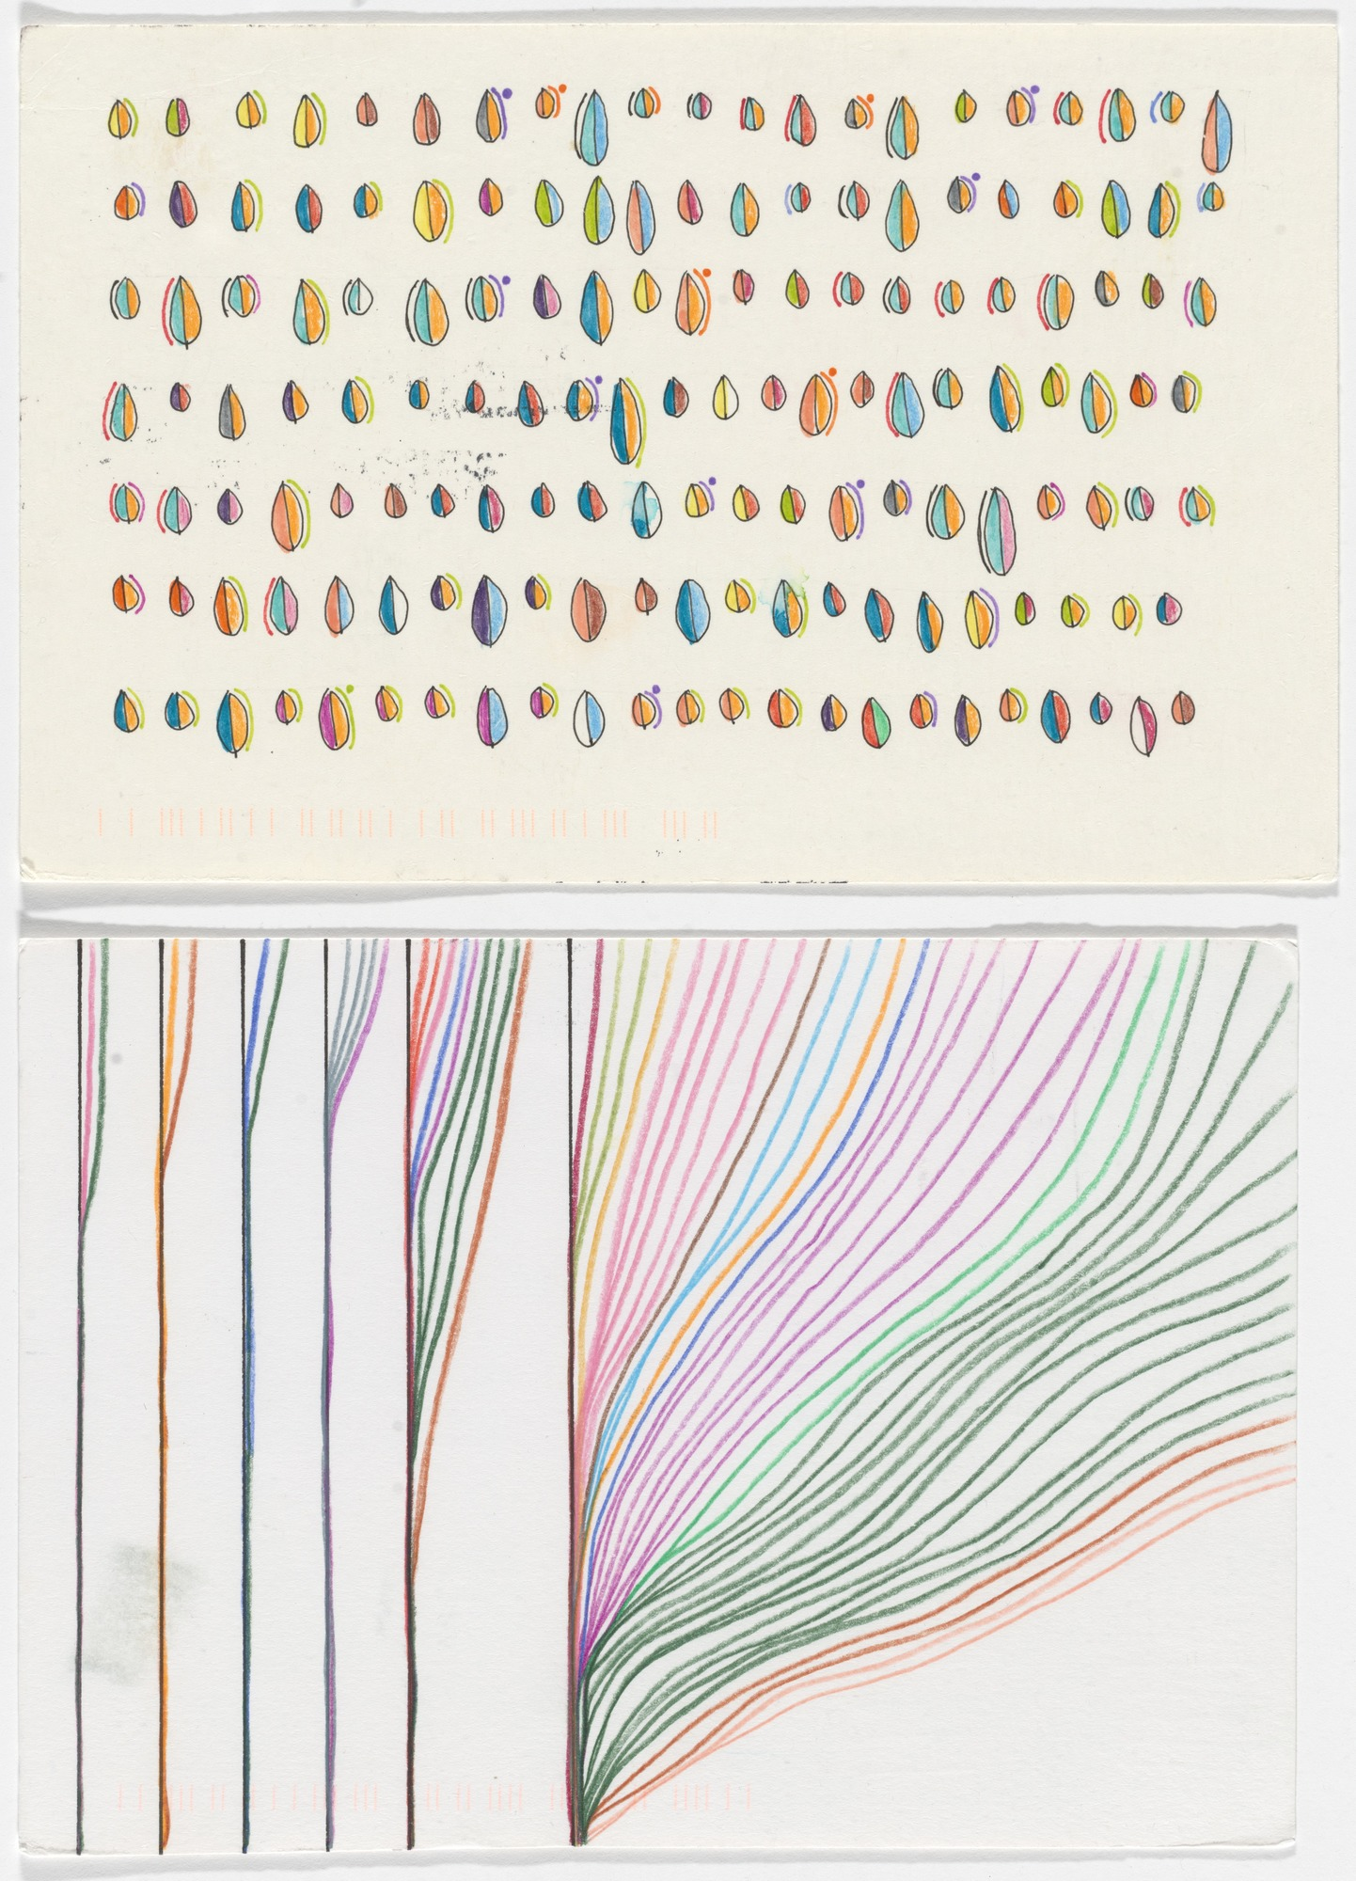

*N.B Think about creating a postcard size artwork and sending it via mail to one of your class mates*

Create your own **data observation** drawing.

What will you be **collecting** data of? Record in your journal.

What **symbols, shapes, lines, colours** will you use to demonstrate the data?

Collect the data for a **week** in your drawing.

Photograph your drawing and the key to your symbols for submission to your teacher.

For example- **looking at the clock**. Different versions of a shape represent where you looked at the clock- watch, phone, microwave (example below).

Extension Task

Data Drawings

