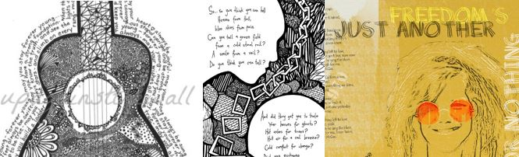

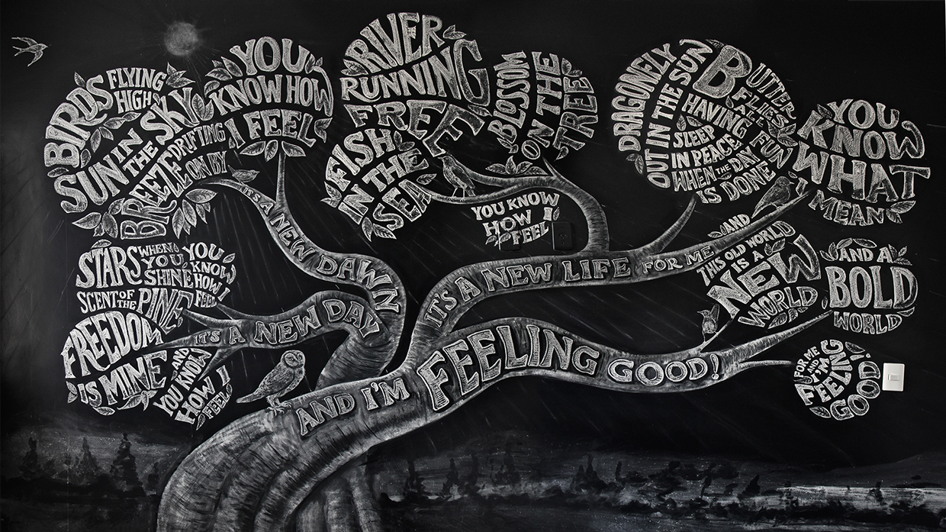
In this unit you will be required to do a drawing that illustrates some lyrics from a favourite song or poem. You will be able to use graphite, grey lead and/or fineliner pens.
JOURNAL ASSESSMENT TASKS:
- Text: tone and line exercises
- Planning of the design including copies of song lyrics
- Reflection

YOUR LEARNING GOALS:
- To develop, plan and create a drawing that uses text as an integral part of the design
- to understand how artist’s use text as an element of design
- To utilise drawing techniques that best represent your idea and intention

