Surrealism in Art –
“Wacky Animals in Wacky Places”.
The Task:
You will create a unique surrealistic animal and will paint a habitat for it to live in.
(Surreal = “unreal, unusual, not-real”)
- Your surreal animal must be concocted of either:
2 different animals; or of 1 animal and 1 ‘inanimate’ object.
P.S. You can draw the animal yourself, or you can cut the images out of a magazine or book.
- Paint the animal’s habitat on a piece of: paper/card and try to think about: the texture of your habitat.
- Also include a brief description about:
the name of the animal (title),
the different animal parts,
the habitat/environment the animal lives in,
the prey/predators of your animal,
and the benefits/difficulties that this animal has.
- Use abstract concepts and design a creative and individual work of art.
- Utilise our knowledge of colours to paint a habitat image. Also consider the element of ‘texture’ when painting the background.
- Use our IT knowledge and literacy skills to write an artist’s statement that explains our work.

- Present a finished canvas that highlights our surreal animal and its habitat.
- Creatively utilise paint and painting techniques in order to create our habitats.
- Successfully use IT facilities and consider size ratios when creating our works.

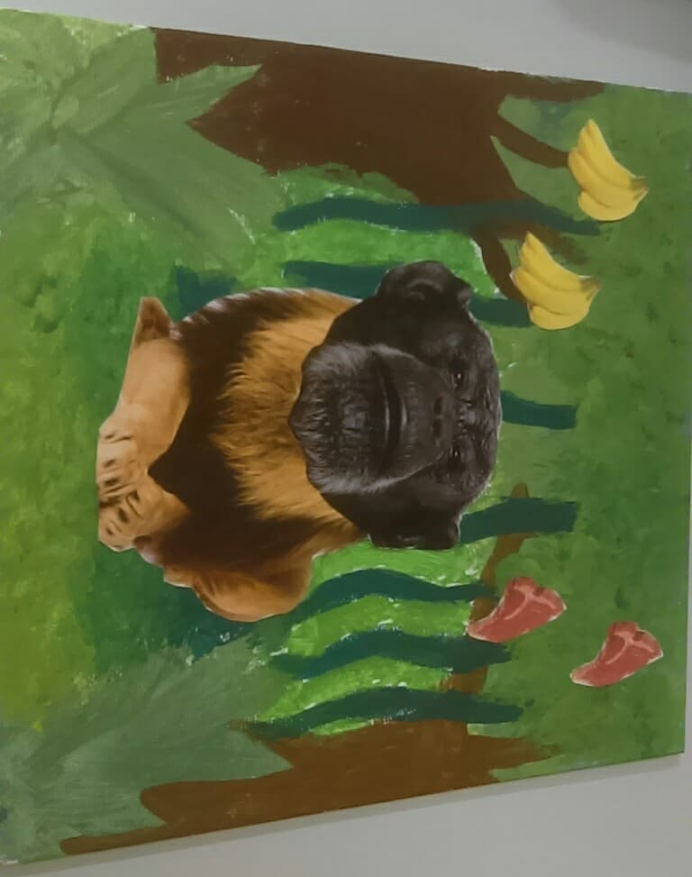

Example:

Surrealism:
“Wacky Animals in Wacky Places”
REFLECTION
Please answer the following questions in your journal

- What was the theme of the task that you were asked to complete, and what have you learnt by completing this task?
_______________________________________________________________________________________________________________________________________________________________________________________________________________
- What two animals/objects did you merge in order to create your surrealistic animal, and why?_____________________________________________________________
__________________________________________________________________________________________________________________________________________
- Did you attempt to mix paint colours for your habitat? If so, which colours did you mix and why?__________________________________________________________
__________________________________________________________________________________________________________________________________________
- Did you incorporate texture into your habitat? If so, how have you demonstrated your understanding of this?_______________________________________________
__________________________________________________________________________________________________________________________________________
- What other Elements of Art can you see in your artwork? _______________________________________________________________________________________________________________________________________________________________________________________________________________
- Are you proud of your work? What aspects would you like the teacher to notice about your work?_______________________________________________________
__________________________________________________________________________________________________________________________________________

POWERPOINT SLIDES (IF NEEDED FOR CONTEXT) 