Journal Project: Stay At Home

Learning Goals
On completion of this unit you will be able to:
- reflect on the ‘cause and effect’ of periods in time and how that influences how you make art.
- design and create artworks based on a theme using different materials you have around their house.
- use art as a means to express your view about the world and current global issues
Materials Needed:
- Your art sketch book
- Drawing materials, any that you have at home, pencil, pen, newspapers, magazines, glue, device (eg. Laptop, phone, etc.).

Outline:
Each lesson you have a prompt to work on in your journal. Try to experiment with as many art materials as you have access to at home.
Week 1
Lesson 1: Complete a series of drawings of your family members while you are looking at them (this is called an observational drawing).
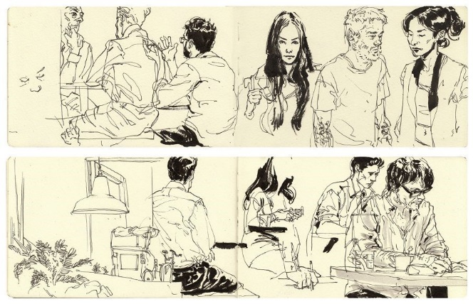
Lesson 2: draw the contents of your fridge.
Week 2
Lesson 1: Cut out and create a collage of a current affairs issue either using newspapers and magazines from your house, or digitally.
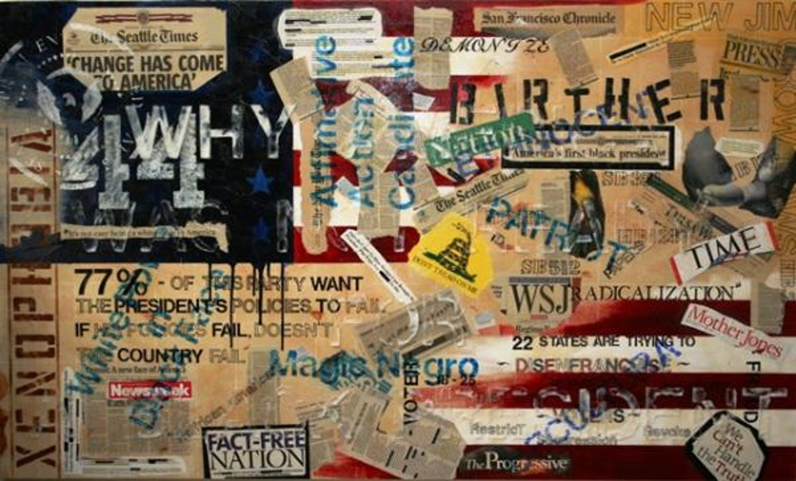
Lesson 2: Create an abstract drawing using data from your week. Use different symbols to represent different activities or things you have done at home. You can arrange the symbols however you like on the page. You can also repeat them as often as you like and you can vary the size for intensity.
