Grade 1/2 :
Week 1: Children will view artworks from the Futurist movement (below) and see how artists have been influenced by technology.
Questions: “How old do you think this picture is?” “Which forms of transport can you see in this image?” “Do we still use these same forms of transport?” “Have they changed at all?” “Are there any forms of technology in this picture?” (What is technology?) “What are some new forms of technology?” “How might this picture look now?” (Image below)

Draw different forms of transport and technology on a few sheets of paper.

Week 2: Drawing continued. Colour using chalk pastels (messy) and pencils.
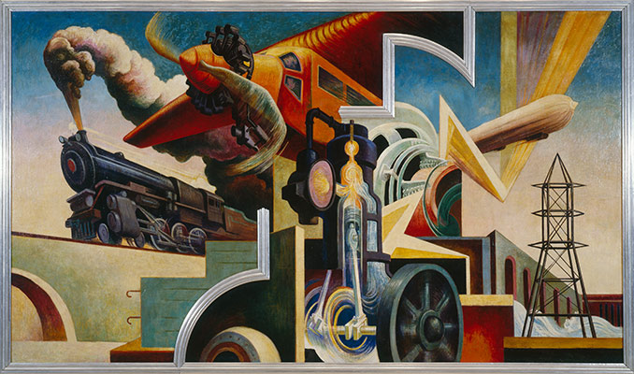

Thomas Hart Benton’s America Today Mural
1930-31

