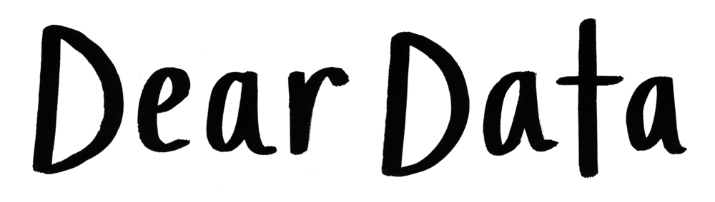

Dear Data is a year-long, analogue data drawing project by Giorgia Lupi and Stefanie Posavec, two award-winning information designers living on different sides of the Atlantic.
By collecting and hand drawing their personal data and sending it to each other in the form of postcards, they became friends.

Each week, and for a year, we collected and measured a particular type of data about our lives, used this data to make a drawing on a postcard-sized sheet of paper, and then dropped the postcard in an English “postbox” (Stefanie) or an American “mailbox” (Giorgia)!
Eventually, the postcard arrived at the other person’s address with all the scuff marks of its journey over the ocean: a type of “slow data” transmission.

Use the following links to investigate this project further.

Website link for more information:
http://www.dear-data.com/theproject
Youtubelink: https://www.youtube.com/watch?time_continue=160&v=iqaVe1MCTlA&feature=emb_logo

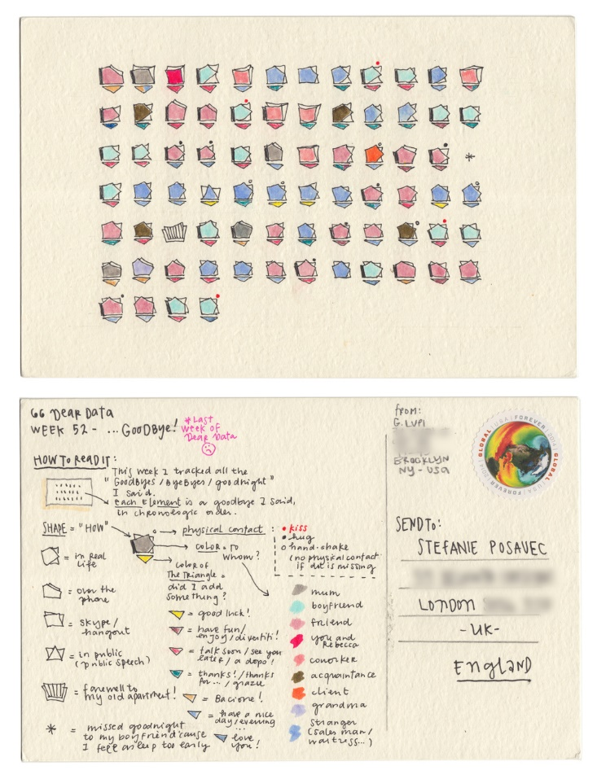
Image via- www.dear-data.com
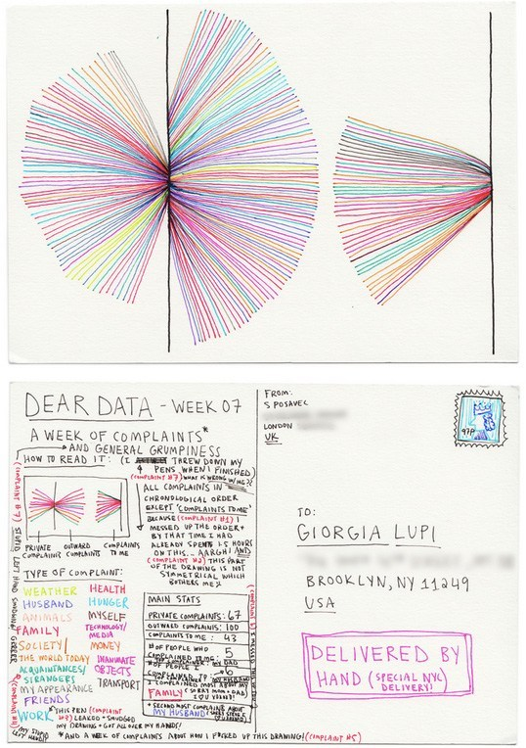
Image via- www.dear-data.com
DESCRIBE  Technique, imagery, presentation, scale, colour | What is a “Data Drawing”?  What does it look like?
CONNECT  Ideas, expression, other artists work, influence, symbolism, interpretation | What is the “Dear Data” project about? Describe what the two artists were trying to do.  What are some of the data collections that the two artists used to create their ‘Data Drawings’?  What ideas do you have for creating your own data drawings? (eg. How many times you checked your phone) BE CREATIVE
RESPOND  Opinion, judgement, feelings, artists intention, your future ideas | What do you think about the idea of tracking data in an analogue way? What are the positives and negatives of this kind of data collection?  How often do you receive something in the mail? How could this project help us re-connect?

