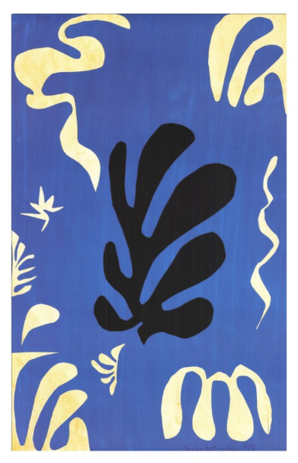
Henri Matisse Shape Cut Outs
You are going to make a shape cut out like Henri Matisse.
A shape is the outline of any object, a shape can be anything, a square is a shape, but so is your hand, a squiggle, a circle and a tree!
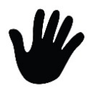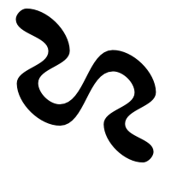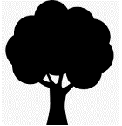
To make your cut out:
- Collect different types of paper from around your house. These could be: coloured paper, tissue paper, newspaper, pages from an old book, paper you paint in different colours, magazine paper, cardboard packaging (this could be a cereal box for example), old birthday cards, wrapping paper, anything you can find that could make your artwork interesting.
- Draw different shapes on your paper. Take care thinking about what size, how many, will they be different shapes or similar or the same, be creative with your shapes like Henri Matisse, they can be squiggly shapes, blobby shapes, sharp shapes, geometric shapes.
- Cut these shapes out using scissors.
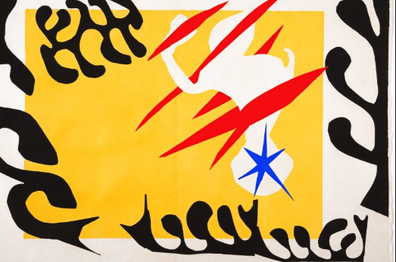
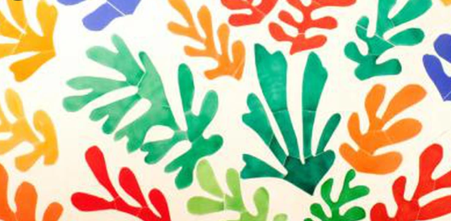
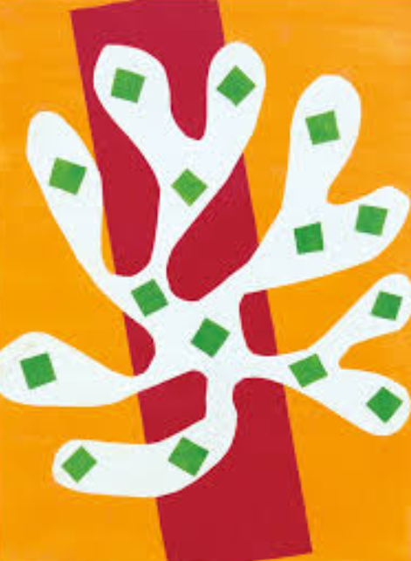
- Arrange them on another piece of paper and then glue them down like the Henri Matisse Cut Outs on this page.

