Art from Natural Materials

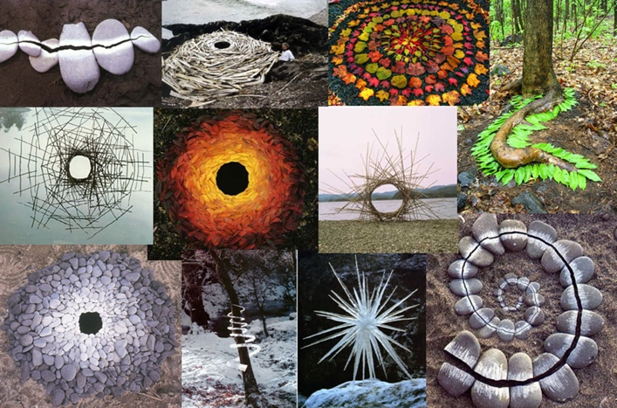
Intended learning outcomes
- Create a sculpture made from natural materials found on the ground.
- Help students appreciate the beauty of natural materials
- Recognise the aesthetic qualities of natural materials i.e. colour, tone, line, texture, pattern, shape and form and use these elements successfully together to make an artwork.
- Explore the concept of time in art.

Learning Experiences
- Create a Goldsworthy inspired artwork outside.
- Take a series of photographs of the artwork as it changes over time.
- Written response to the work of Andy Goldsworthy and Lola Greeno.

You will need
- Materials from the environment outside
- A device to take a photo

What you need to do
- Watch the YouTubes about Andy Goldsworthy
https://www.youtube.com/watch?v=FPDH8yCnlk0
https://www.youtube.com/watch?v=O9TyHzP-8b8
https://www.youtube.com/watch?v=fIQKZghtyiY
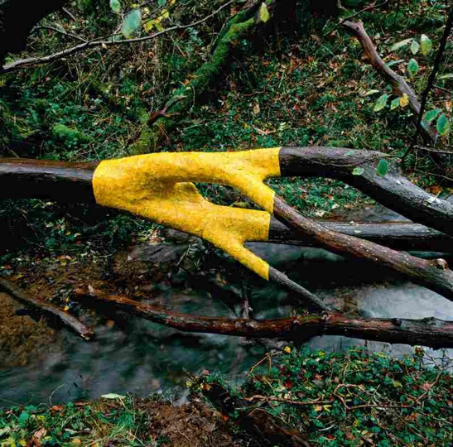
- After looking at the work of Andy Goldsworthy go outside into your garden or go for a walk. Collect natural materials from the location and start to plan a sculpture like Goldsworthy. You may want to draw some ideas in your art journal.
- Make a sculpture the responds to the environment.
- Photograph or video the artwork. If you can manage take a series of photos that shows how the artwork changes over time.

Who is Andy Goldsworthy?
Find out about the artist Andy Goldsworthy
- British artist who has been making Land Art since the 1970s.
- Works with natural forms in their environment.
- Does not damage the natural environment, but works in harmony with it.
- His work is governed by time and changes in the environment. “Real change is best understood by staying in one place. When I travel I see differences rather than change”
- He works in a way that is sensitive to the cycle of life, the past the present and the future.
- His work is temporary and transient and will eventually disappear, all that is left is the photographic record.

Questions
  - Imagine coming across one of Goldsworthy’s sculptures, how would this make you feel?
  - How does Goldsworthy use combinations of elements like colour, texture, line, tone, pattern, repetition, shape and forms to get our attention and make his artwork stand out in the environment?
  - How do you think Goldsworthy makes his sculptures? How does he get them to stay together?
  - Lola Greeno is a Tasmanian Aboriginal artist find an example of her artwork. How is her art similar to Andy Goldsworthy’s sculpture, and how is it different?

Assessment
Making
Manipulates materials, techniques and processes to represent ideas and subject matter in their own artworks.
- Purposeful and skilful manipulation of materials, techniques and processes
Responding
Can evaluate how representations communicate artistic intentions in artworks they make and view
- Consistently identifies and analyses how artists use visual conventions to communicate intentions. This is documented extensively and in depth in the Art journal
Identify influences of other artists on their own artworks
- Creates an artwork that responds with some sophistication to the work of other artists and an exploration of techniques and processes.
- The student can identify and analyse how visual art conventions and design principles are applied to their own work, and can explain how they communicates meaning when making artworks.

Goldsworthy Andy, 2004 “ Time” page 7, Thames & Hudson, UK

