Leaf Homework Year 7
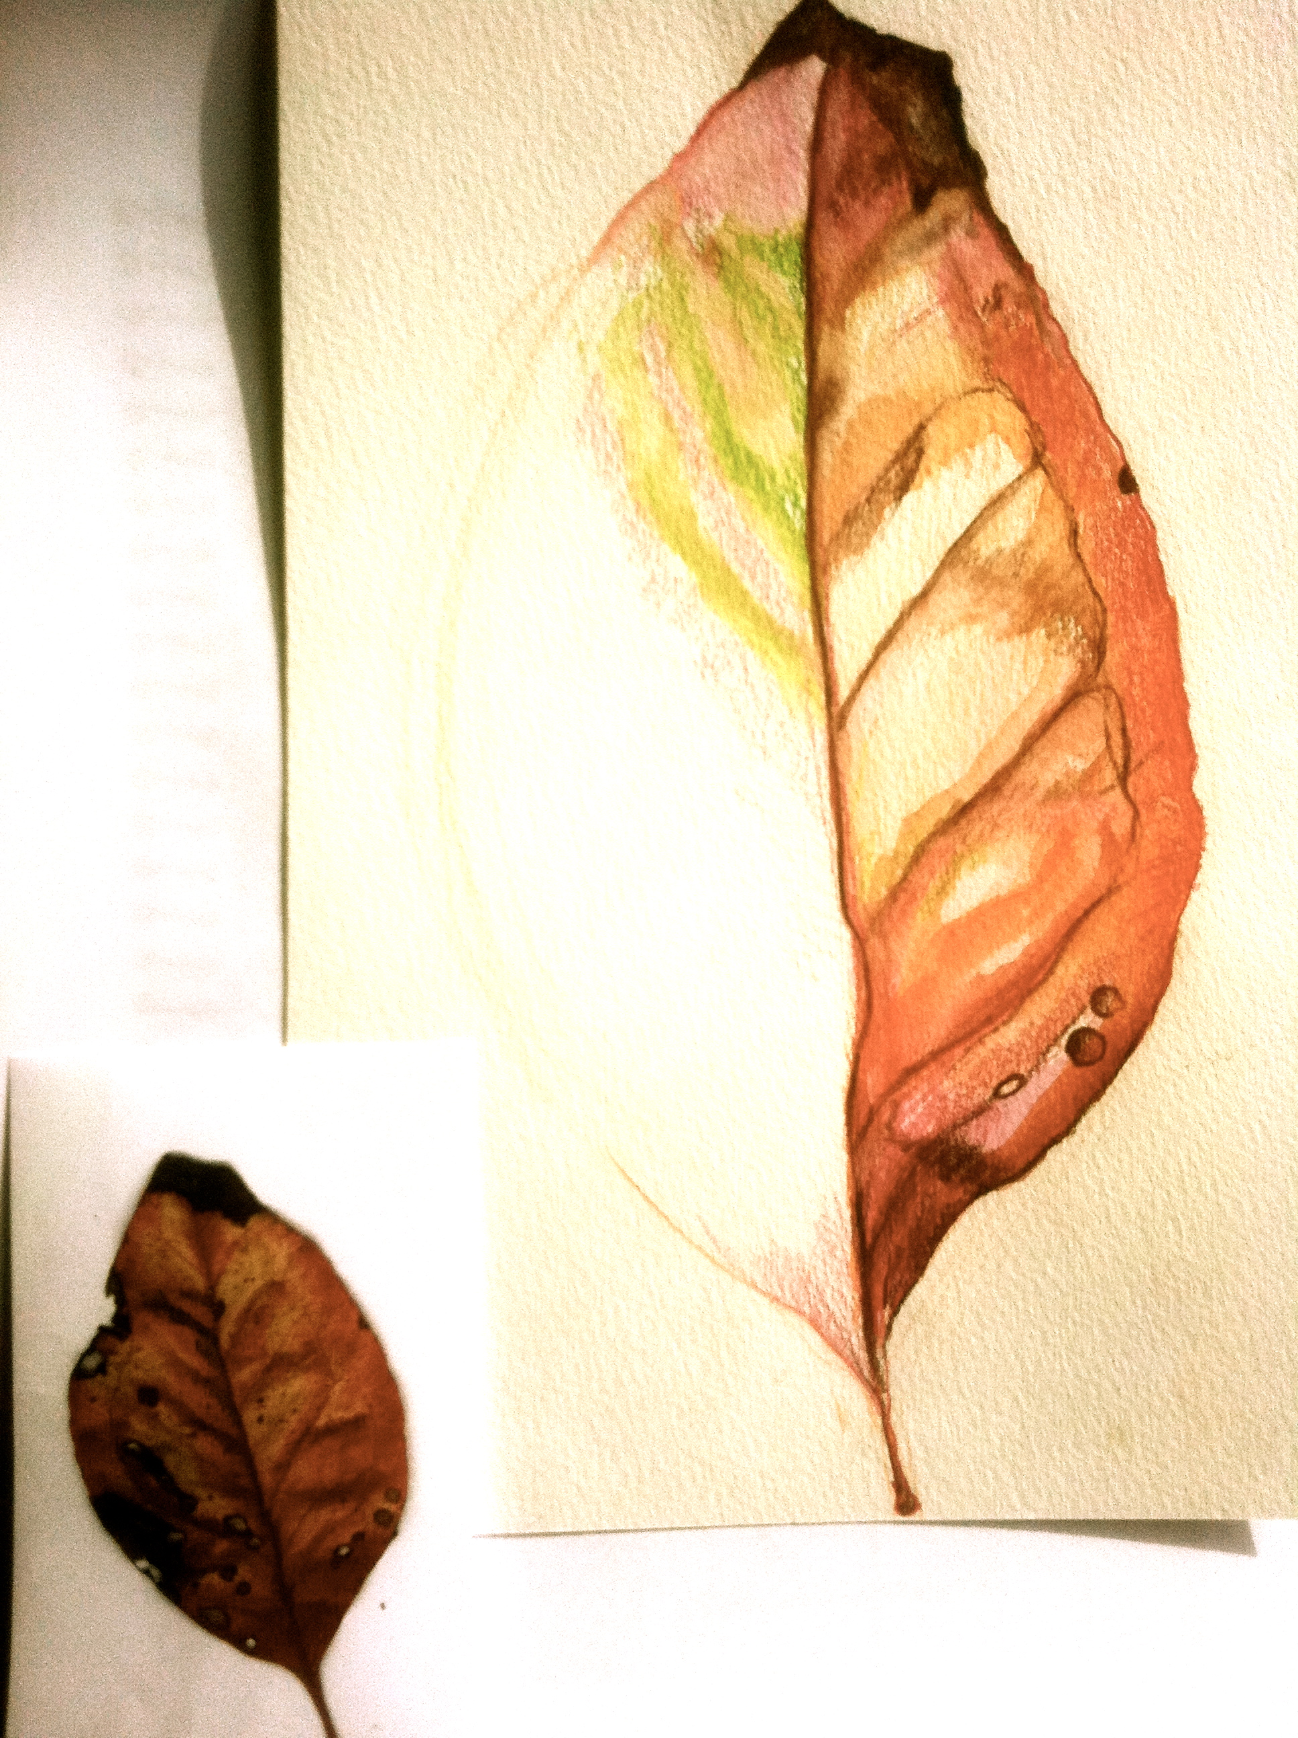
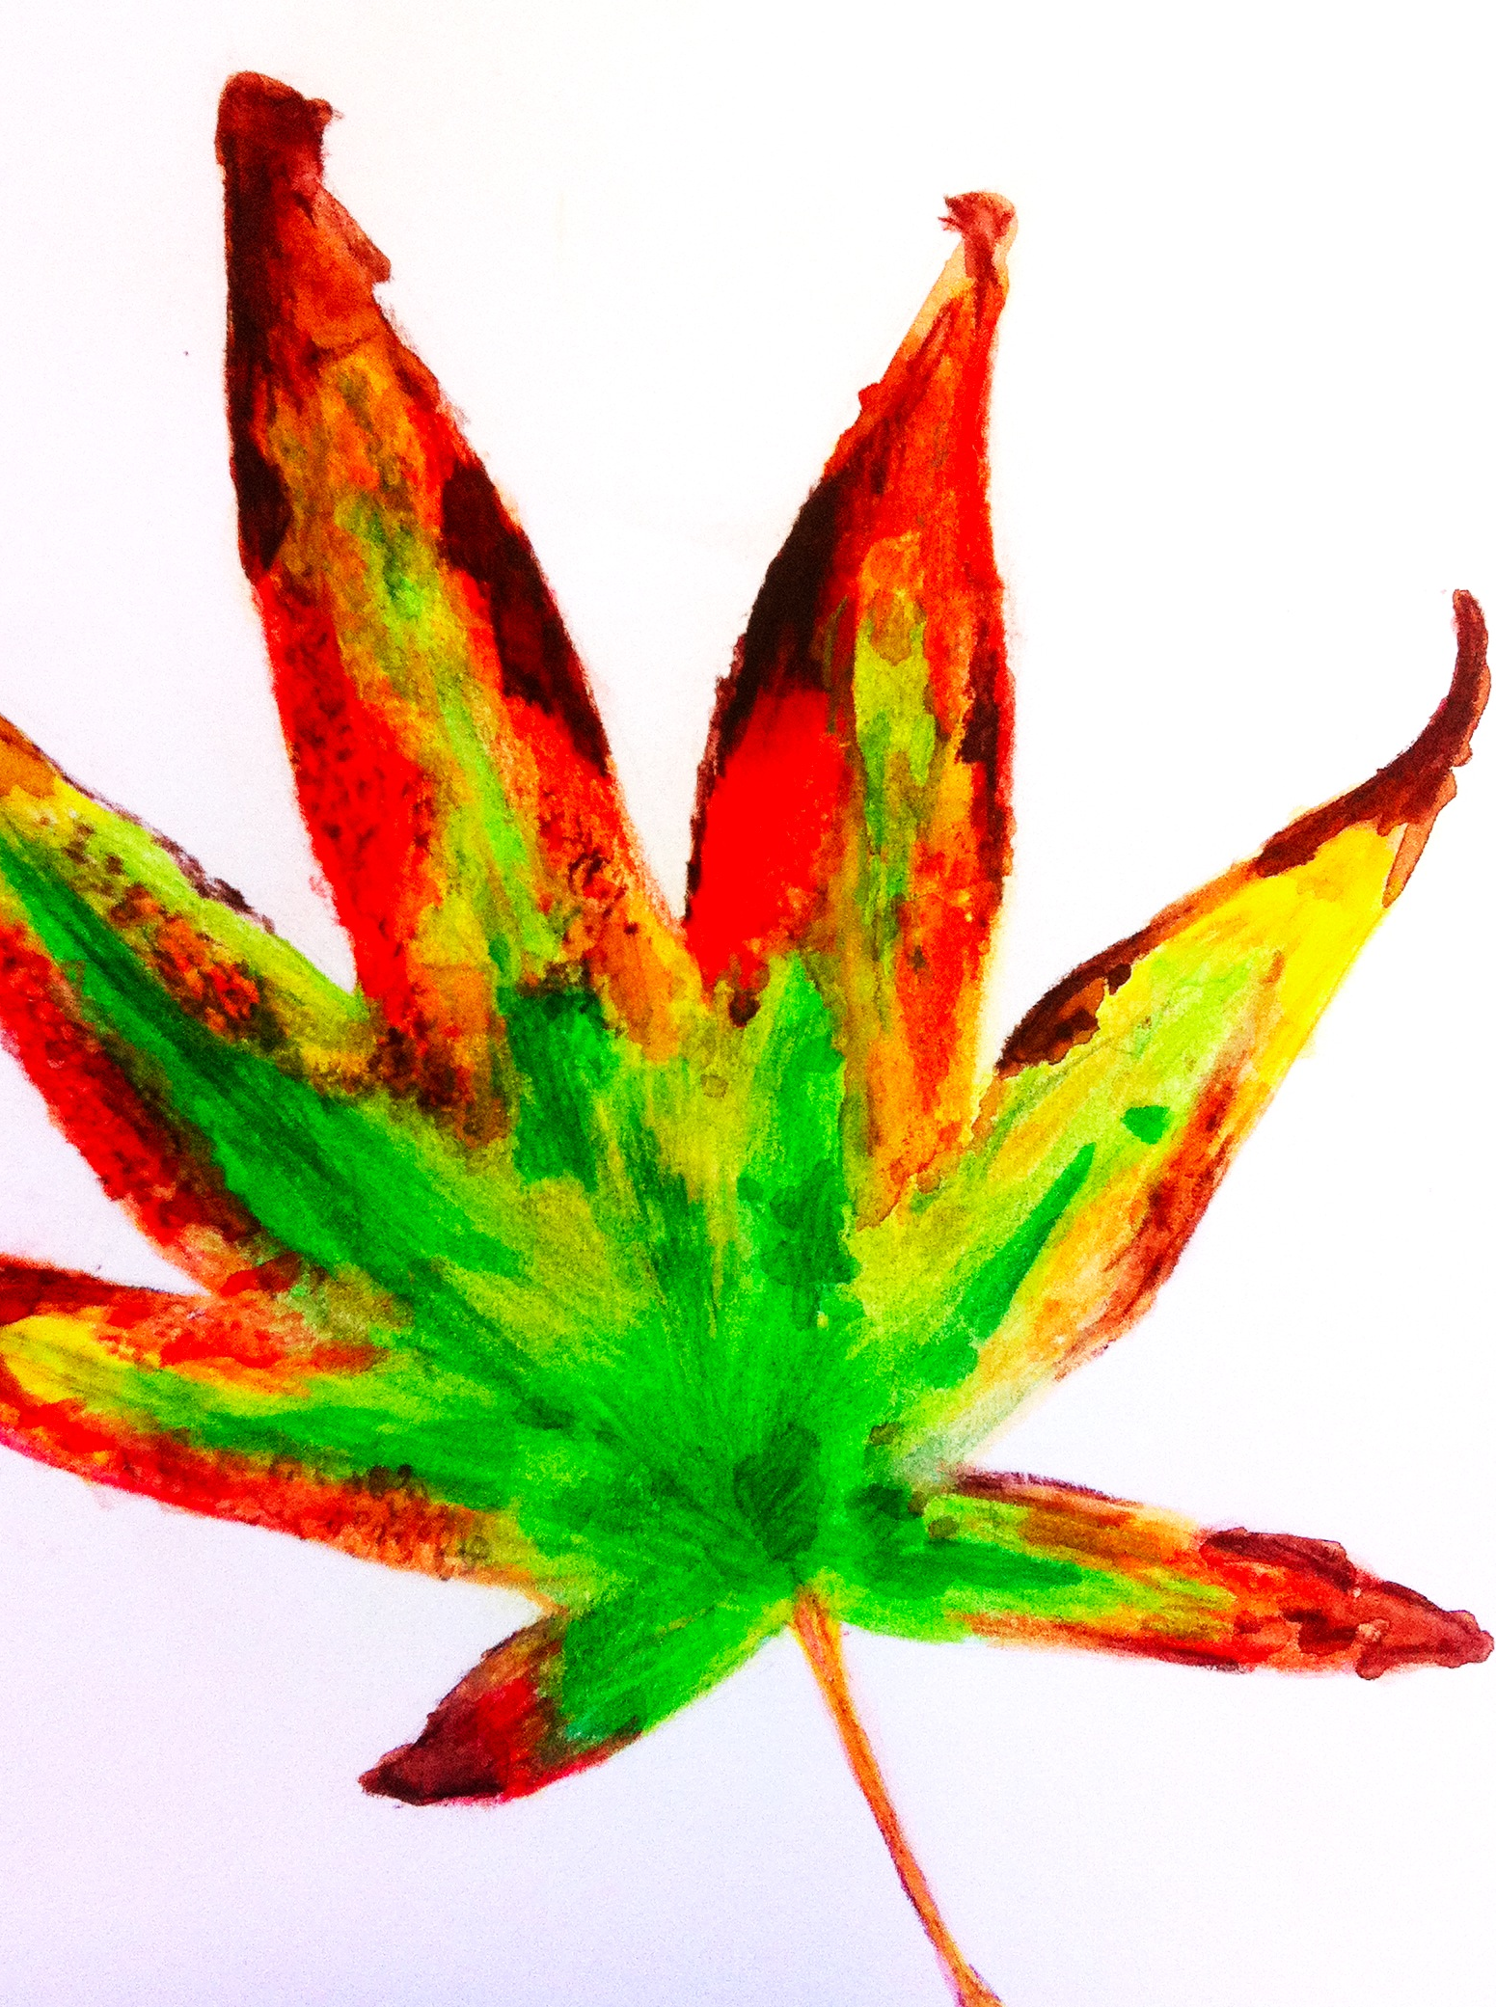
Our seasons are changing and you have probably noticed the leaves turning and falling throughout Autumn. Your homework this week is to draw and paint in colour an Autumn leaf (provided as a small colour photocopy). Use a page in the sketchbook and enlarge the leaf to be able to portray the detail and colour on its surface. Stick the colour copy on the same page. Look at the example here. Use your pencil sets.
Due :

Leaf Homework Year 7
Our seasons are changing and you have probably noticed the leaves turning and falling throughout Autumn. Your homework this week is to draw and paint in colour an Autumn leaf (provided as a small colour photocopy). Use a page in the sketchbook and enlarge the leaf to be able to portray the detail and colour on its surface. Stick the colour copy on the same page. Look at the example here. Use your pencil sets.
Due :

Leaf Homework Year 7
Our seasons are changing and you have probably noticed the leaves turning and falling throughout Autumn. Your homework this week is to draw and paint in colour an Autumn leaf (provided as a small colour photocopy). Use a page in the sketchbook and enlarge the leaf to be able to portray the detail and colour on its surface. Stick the colour copy on the same page. Look at the example here. Use your pencil sets.
Due :

April 10th, 2020 Courtesy of Miriam Berkery, The Friends School, https://tata.org.au/

