Journal Project: Stay At Home

At the beginning of each lesson the teacher will hold a canvas video conference with their class explaining the journal project theme for the lesson, they will then do a demo for the lessons topic discussing with students different techniques, tips and materials they could use at home to complete each lesson.

Discuss the importance of journaling particularly at this time, making sense of the new changes that are happening around us.

It is expected that all students have their art journals with them at home and were collected from school in Term 1.

Students will then use the rest of the lesson to create their own.

On completion of week 2, students will continue to work in their journal each lesson, but only for the beginning of the lesson using further prompts that will be provided. Students will also be encouraged for continue working on these in their own time. Encouraging the continuity of journaling.
During the first two weeks of term two, students will be focusing on completing a journal project using the provided prompts. This gives staff a chance to organise and clarify, if possible art packs for future lessons.

Learning Goals
On completion of this unit students will be able to:
- reflect on the ‘cause and effect’ of periods in time and how that influences how they make art.
- design and create artworks based on a theme using different materials they have around their house.
- use art as a means to express your view about the world and current global issues
Materials Needed:
- Sketch book (all students have their own which should be at home with them
- Drawing materials, any that they have at home, pencil, pen, newspapers, magazines, glue, device (eg. Laptop, phone, etc.).

Outline:
Each lesson you have a prompt to work on in your journal. Try to experiment with as many art materials as you have access to at home.
Week 1
Lesson 1: Complete a series of drawings of your family members while you are looking at them (this is called an observational drawing).
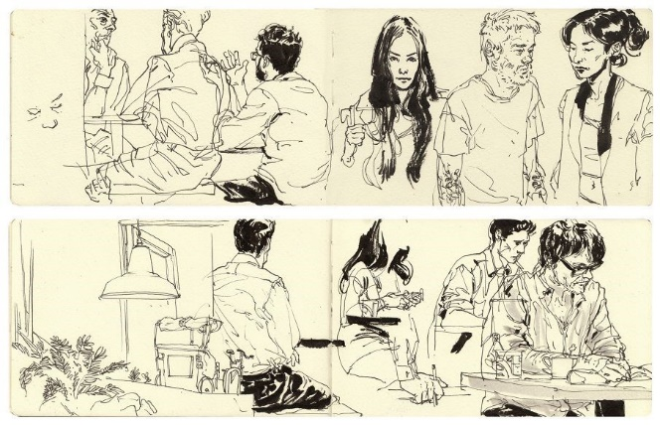
Lesson 2: draw the contents of your fridge.
Week 2
Lesson 1: Cut out and create a collage of a current affairs issue either using newspapers and magazines from your house, or digitally.
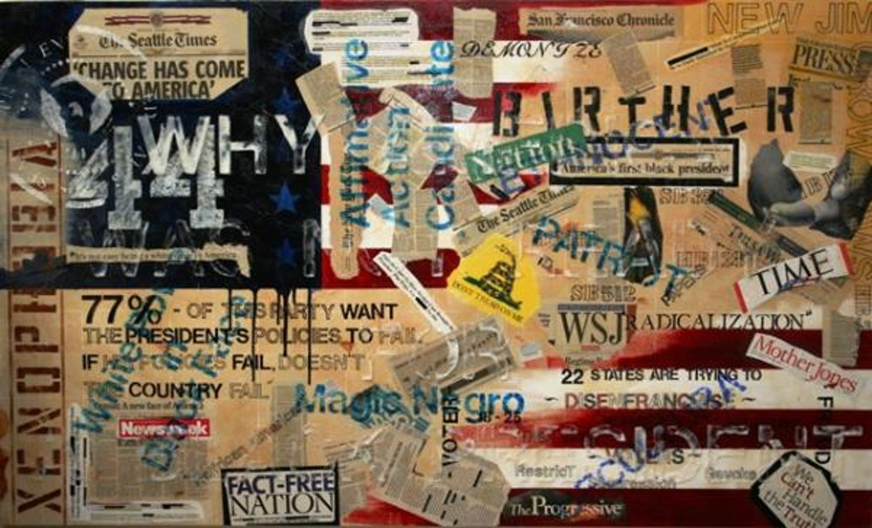
Lesson 2: Create an abstract drawing using data from your week. Use different symbols to represent different activities or things you have done at home. You can arrange the symbols however you like on the page. You can also repeat them as often as you like and you can vary the size for intensity.
