Annual Report 2020-2021
Contents

Treasurers Report

The Tasmanian Art Teachers Association Inc. (TATA)
Treasurer’s Report for AGM
Reporting Period 16th of November 2020 to 04th November 2021

Balance of TATA Accounts –16/11/2020 to 04/11/2021

The balance of the TATA MyState Bank Account at the start of the reporting period was $29,367.68

Income for TATA –16/11/2020 to 04/11/2021

TATA’s income into the TATA MyState Bank Account for the duration of the reporting period was $804.64.
This included:
- $75.00 as Eventbrite ticketing for TATA PL
- $729.64 in membership through Stripe and direct credit

TATA no longer holds a PayPal account.

All membership transactions that come in via the Website Form have now moved to Stripe. These payments are deposited directly into the TATA MyState bank account.

Expenses for TATA –16/11/2020 to 04/11/2021

The operating costs and expenses for TATA over the reporting period were $2617.27.
This comprised of:
- Website related expenses incurred $775.00
- Insurance for the TATA was also paid - to the amount of $339.00
- Annual Return of Association- $153.90
- PL related expenses for No Place Like Home and other- $1018.46
- Reimbursements for overcharge on Membership- $315.91
- Swift Fee for ticketing on Eventbrite- $15.00

Total Expenses for the reporting period was $2617.27

Current Balance of TATA Accounts

As of the 4th of November 2021, the current balance of the TATA MyState Bank Account is $27,555.05. The balance held in Stripe is $0.00.

There is no petty cash held by the TATA Treasurer for day-to-day purposes.

Further clarification on how monies have been transacted for the reporting period can be seen in Appendix 1, the MyState transactional history, and Appendix 2, the Stripe Reports Overview.

Appendix 1
Financial Report MyState Account – Item List
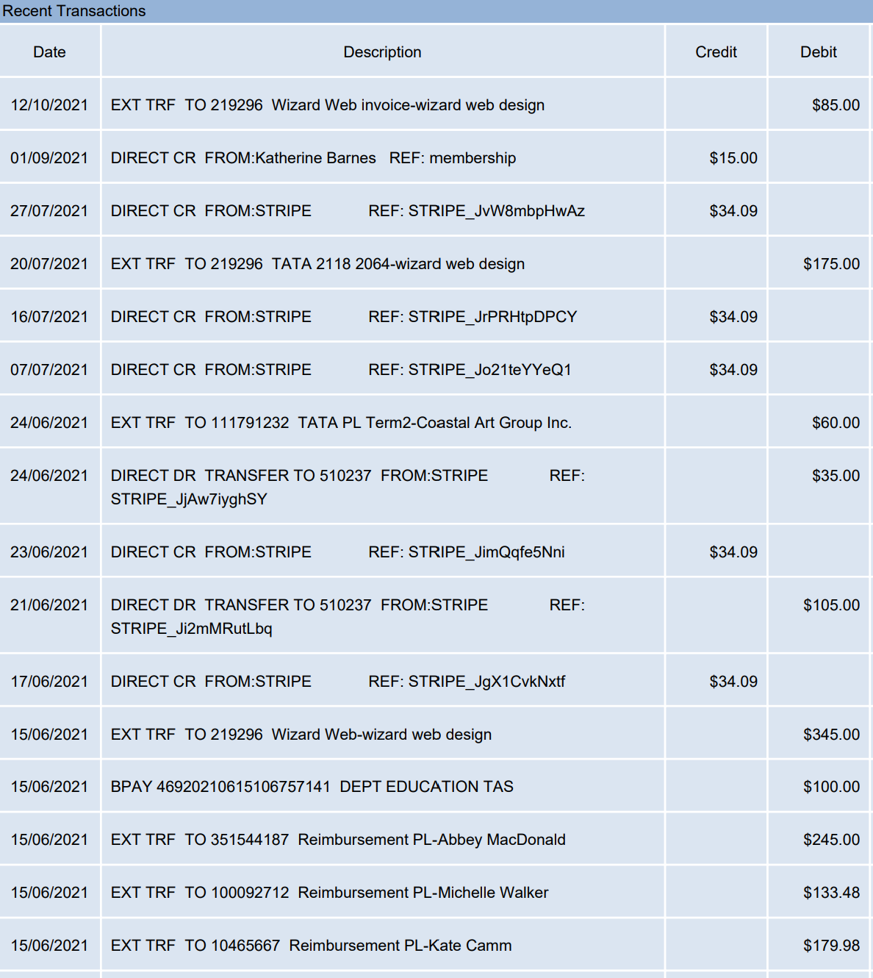

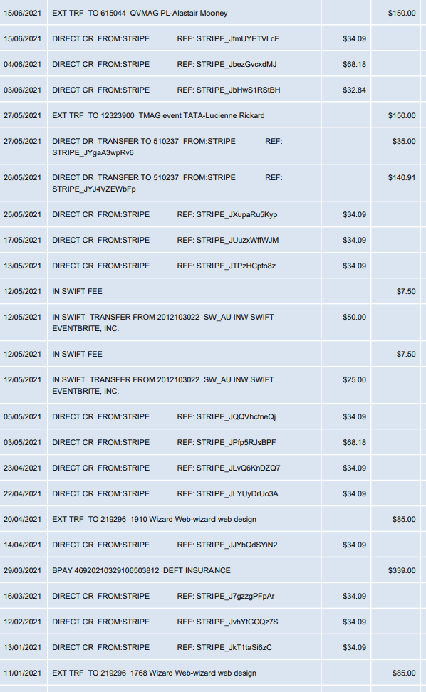

Summary | Amount in $
Balance Period Start | $29,367.68
Total Income | $804.64
Total Expenditure | $2617.27
Current Balance | $27,555.05

Appendix 2

Stripe Reports Overview
Data from Stripe for the period 01/11/2020- 30/11/2021
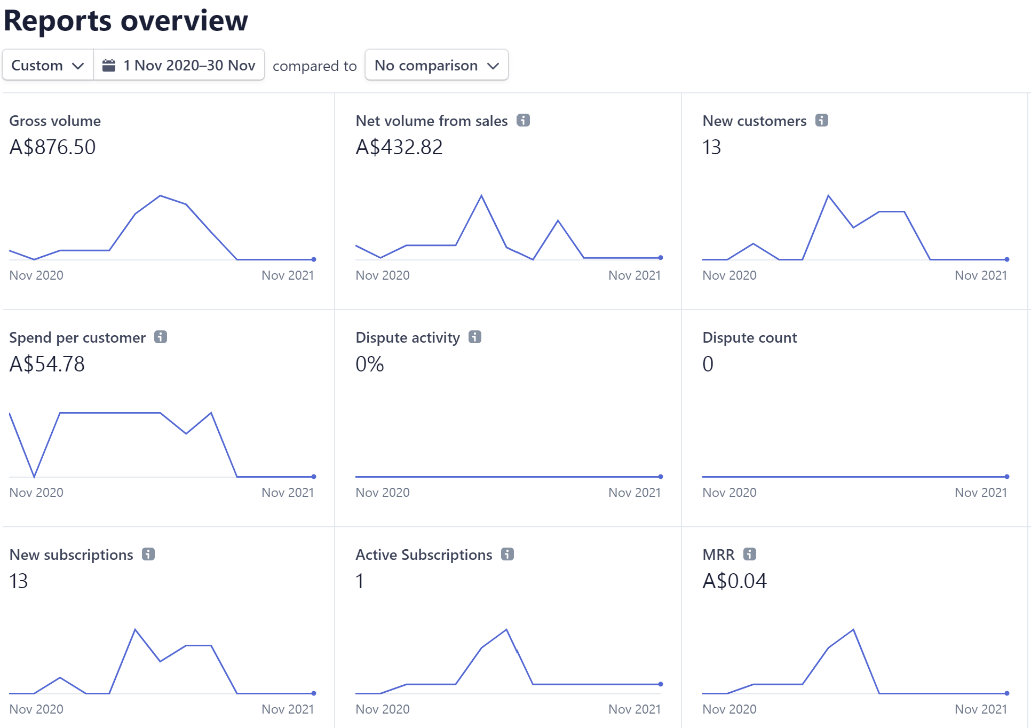

Ongoing issues with Stripe. Membership was changed to subscription and began to be recurring. Multiple refunds required through Stripe error. Pause on membership drive due to unresolved issue.
Membership drive Jan 2022- membership for calendar year.

President’s Report
TATA Social Media and Website
TATA continues to have a strong social media presence with 322 followers on Instagram. This has increased by 127 since this time last year. Our Facebook page continues to be our strongest platform to reach our followers on with 961 followers. This is an increase of 151 followers from this time last year. A big thank you to Antonio Zanchetta, Caz Saunders and Abbey MacDonald for all their work in these spaces. TATA constantly posts on our Facebook page and Instagram account. We also use these spaces to answer queries from members and advertise events and share relevant information. The council feels that these spaces should be utilised even more in 2022. We will make sure that with the launch of our new website followers on both platforms will be directed to our Membership page.
The website began to show issues earlier in the year. There were ongoing problems throughout the year with the page charging members incorrect amounts, as opposed to a one-off annual payment for membership it was charging members an ongoing monthly payment. We had issues finding out where this bug was coming from, after advice from an external business, who specialise in websites for associations, we agreed to change our website provider and build a new one. Stripe, which manages our membership finance side of things was likely not the issue but rather the website. From advice from these professionals the council agreed we would build a new website utilising Square Space, a trusted and affordable website building company who offer ongoing customer support. Throughout this ongoing issue of managing the website we also decided to no longer use the services of Louise from Wizard Web. We parted on very good terms. A massive thank you to Michelle Walker for building the entire new website and to Antonio Zanchetta for his help with this as well. Antonio continues to do a lot of work to maintain our website and make sure our members can access important digital resources. Thank you for all of your hard work on this Antonio.
The council recognised this a year less of a take up with emails from TATA to Members. Mail Chimp provides data about how many members access their emails. We are hoping to educate our members about Outlook’s recent changes to inboxes and show our members how to make emails from TATA go in to their ‘focussed’ inbox rather than their ‘other’ inbox.
Changes to Membership Cycle
In order to help manage the website issues the council decided to change our membership cycle to run from January-January instead of July-July. We also felt this would help with any confusion about when members needed to renew their membership. After advertising and hosting a Special General Meeting we successful amended to constitution to change the membership cycle.

TATA Collaborations with Professional Arts organisations and events
TATA & Hadley’s Art prize
After being cancelled in 2020, Hadley’s Art Prize was able to go ahead this year. There was further consultation between TATA and Hadley’s in the construction of the Education Kit, which accompanies the prize. This fantastic resource aligns with the Australian Curriculum and is a valuable planning resource. Members of our council provided feedback and insights for this education kit. Thank you to Abbey MacDonald for orchestrating this and allowing so much in put from TATA and classroom teachers.
ACARA PL Events- There’s No Place Like Home
On the 3, 4 and 5 May this year ACARA Arts curriculum specialist Robyn Carmody came down to Tasmania to speak with our teachers about the recent changes to the Australian Arts Curriculum and provide some PL on how to navigate the new curriculum. She also spoke to teachers about how to provide feedback to ACARA about these changes. In collaboration with Tasmanian Museum and Art Gallery (TMAG), Queen Victoria Museum and Art Gallery (QVMAG) and Burnie Coastal Arts Group, TATA offered three opportunities for art teachers to be part of these conversations in the south, north and north west.
In Burnie internationally renowned local artists Nerrisa Lea and Reg Lynch will spoke about their exhibition, ‘Remember the Humanness’. Their work introduces audiences to two exciting art practices in equal parts by the skill and meticulous execution of Lea’s surreal paintings and the wry humour and sardonic view of Lynch’s world. Beverly McNamara and Alex Nichols who have worked for Disney will share how to make a living as an artist. Burnie Coastal art group and Artscape will share how teachers and students can interact with community art spaces.
In Launceston Tasmanian contemporary artist Alastair Mooney spoke about his NEST exhibition at QVMAG, and a Senior Curator in Visual Art and Design engaged the audience in conversation about what's happening at QVMAG.
In Hobart TMAG hosted Tasmanian contemporary artist Lucienne Rickard who spoke about her new Ecology Studies project, and TMAG’s Principal Art Curator, Jane Stewart, who engaged the audience in conversation about the Hobart Current: LIBERTY exhibition.
Prof Standards for teachers
2. Know the content and how to teach it
3. Plan for and implement effective teaching and learning
6. Engage in professional learning
7. Engage professionally with colleagues, parents/carers ad the community

This event cost $25.00 for non-members and was free for members. There were 39 participants overall at these events. It was fantastic to be able to engage with local galleries, art spaces, artists and curators as part of this event. TATA paid these people in line with NAVA rates.
Open Classrooms
Last year due to COVID, open classroom were moved online. This year each host for the Open classrooms could choose whether they wanted their event to be live online, pre-recorded or in real life. Thank you to Miriam Berkery, Caz Saunders, Nina Eberhardt (Burnie primary educator), Sarah Brooker, Luke Viney and Kate Camm for hosting these events. Unfortunately, there was no live take up with these events. We are working as a council to re-imagine the Open Classrooms for next year. We feel it is still a beneficial event for our members. Thank you to Caz who recorded her session, and it is now available on our website.
Future events with Salamanca Arts Centre & Gallery Seventy-One
Throughout October and November Kate Camm has been in discussions with Salamanca Arts Centre about a partnership between them and TATA. TATA wrote a letter of support to accompany a grant application for some RISE funding. In this application SAC are asking for some money to help support three main initiatives with TATA.
- To pay ArtRage exhibiting artists to speak to visiting school group about their work and experiences
- To pay for some high-quality video’s where artists showing at SAC discuss their work and create educational resources around these artists and their work for teachers to use in the classroom
- A professional Learning event for teachers in the form of a gallery crawl, where other galleries are involved in an evening event. This could happen across the state and doesn’t just have to be in the South.
UTAS Panels
On two occasions Kate Camm spoke on UTAS Panels addressing students studying Master of Teaching about being a Visual Art Teacher. These events were great to meet pre-service teachers and provide them with practical advice as well as an opportunity to discuss issues and ask questions. Thank you to Abbey MacDonald for organising these events and asking TATA to be a part of them.
Devonport Primary Visual Arts Educators
During our AGM on 11 November, Sarah Brooke hosted a whole day PL event called ‘Visual Arts PL for Primary and Secondary Teachers’. This event was hosted at the Devonport Regional Gallery and had 16 attendees. At the end of the PL Sarah linked her group in with the TATA AGM. This attracted a new member to our Council for 2022. Thank you and congratulations to Sarah for a very successful event.
Areas of priority against TATA Strategic Plan objectives
Significantly this year with the finalising of the ACARA Arts curriculum TATA felt it was very important to provide as much support to our members as possible. Hosting the ‘No Place Like Home’ events was crucial in order to provide our members with an opportunity to unpack, understand and provide feedback around this new curriculum. This event also offered face to face networking, something that as lost due to COVID in 2020, and desperately needed. This aligns with our two main objectives: Professional Learning and Advocacy.
A specific meeting of council will be made in January 2022 to rewrite our Strategic Plan. We are currently considering the best format for this plan.

Acknowledgments
Thank you to the TATA Executive and Council for your guidance and support in my first term as President. Your ongoing passion and enthusiasm for Visual Arts education has meant TATA has continued to grow and meet the needs of our members. Special Thanks to:
- Michelle Walker- Vice President
- Hannah Derbyshire- Treasurer
- Sarah Brooke- Secretary
- Antonio Zanchetta- Webmaster and Social Media Communications
- Miriam Berkery
- Steve Richter
- Jan Hogan
- Katie Wightman- Immediate Past President
- Abbey MacDonald- Councillor
- Luke Viney- Councillor
- Caz Saunders- Councillor
- Bree Taylor- Councillor
- Melissa Heathorn- Councillor

Kate Camm
President 2021

